PERSONAL FINANCE

CONSUMER RIGHTS: WHEN A PURCHASE GOES WRONG
ANSWER KEY ACTIVITY

PART 1

Consumer Rights Reference Guide - Complete the Missing Terms

Term | Definition
Consumer rights | The protections a buyer has when a purchase goes wrong
Refund | Getting your money back for a returned or defective product
Return policy | A store's rules for when and how you can bring an item back
Chargeback | Asking your credit card company to reverse a charge for a bad purchase
FTC (Federal Trade Commission) | The federal agency that protects consumers from unfair or deceptive business practices
Warranty | A company's promise to repair or replace a product that breaks within a set time
Escalation ladder | The step-by-step order for fixing a bad purchase, from contacting the seller up to court
Dispute | Formally challenging a charge or a seller's decision
Small claims court | A simple, low-cost court for settling money disagreements without a lawyer
Receipt (proof of purchase) | The record that shows what you bought, when, and for how much

PART 2

Apply the Terms - Consumer Rights Vocabulary in Context
WORD BANK FTC · consumer rights · escalation ladder · return policy · small claims
1. The protections a buyer has when a purchase goes wrong are called your consumer rights.
consumer rights
2. A store's rules for when and how you can bring an item back are called its return policy.
return policy
3. The federal agency that protects consumers from unfair or deceptive business practices is the FTC (Federal Trade Commission).
FTC
4. The step-by-step order for fixing a bad purchase, from contacting the seller up to court, is called the escalation ladder.
escalation ladder
5. A simple, low-cost court for settling money disagreements without a lawyer is called small claims court.
small claims

PART 3

Name the Right Step - Place the Situation on the Escalation Ladder
1. As Marcus Reed, a shopper says: "I bought $180 headphones online. They arrived with a cracked earcup. I emailed the seller a photo and my order number three times over two weeks, and they have stopped answering. I paid with my credit card."
(a) What right is this buyer claiming?
(b) Which rung of the escalation ladder is the RIGHT next step, and why?
(c) What should the buyer do at that step?
(1) The right claimed: the right to a refund, replacement, or repair for a product that arrived broken (defective / not as described) - consumer rights, backed by the order confirmation as proof. (2) Right next step - RUNG 3, a CHARGEBACK: the buyer already tried rung 1 (contact the seller) and got ignored, and they paid by credit card, so the next rung is to dispute the charge with the card company. (3) What to do: call the credit card company, explain the headphones arrived broken and the seller will not fix it, attach the order confirmation and photos, and ask them to reverse the $180 charge. Accept: right to a refund/replacement for a defective item; rung 3 / chargeback as the next step; and contacting the credit card company with proof to reverse the charge.
2. As Marcus Reed, a shopper says: "I bought a jacket in the store four days ago, still with the tags on and the receipt. It does not fit. The cashier just told me 'no returns' even though the sign says 30 days."
(a) What right is this buyer claiming?
(b) Which rung of the ladder is the RIGHT next step?
(c) What should the buyer do?
(1) The right claimed: the right to a return under the store's posted RETURN POLICY - the item is inside the return window (4 of 30 days), unused, with tags and receipt, so a return is owed. (2) Right next step - RUNG 2, ESCALATE TO A MANAGER: the front-line cashier said no, but this is not yet a chargeback situation (the buyer has a receipt and the policy in writing), so escalate one rung. (3) What to do: politely ask to speak with a manager or customer service, show the receipt and point to the posted 30-day return policy, and request the return or refund. Accept: right to a return within the posted return policy; rung 2 / escalate to a manager as the next step; and showing the receipt and the posted policy to a manager.
3. As Marcus Reed, a shopper says: "A repair shop took a $300 deposit to fix my laptop, never did the work, and closed. I paid in cash, so there is no card to dispute. I already contacted them, escalated, and filed an FTC complaint, but I still have no money and no repair."
(a) What right is this buyer claiming?
(b) Which rung of the ladder is the RIGHT next step, and why is a chargeback NOT available?
(c) What should the buyer do?
(1) The right claimed: the right to get the paid-for service (or the $300 back) - the shop took money and delivered nothing, which is a breach the buyer can pursue. (2) Right next step - RUNG 6, SMALL CLAIMS COURT: the buyer has already climbed rungs 1, 2, and 4 (contacted, escalated, filed an FTC complaint), a chargeback (rung 3) is NOT available because they paid in cash (only a credit card gives chargeback protection), and $300 is worth pursuing, so the last resort is small claims court. (3) What to do: file in small claims court, pay the small filing fee, and bring the proof (deposit receipt, messages, the FTC complaint) to explain the case to a judge - no lawyer needed. Accept: right to the service or a refund; rung 6 / small claims court because a cash payment blocks a chargeback and lower rungs failed; and filing with proof in small claims court.

PART 4

Read the Chart - How Long Each Step Takes
As Marcus Reed, study the bar chart titled "Fixing a Bad Purchase: Typical Days to Resolve at Each Step" (it appears with A4-Q1). Each bar is one step on the escalation ladder, and its height is how many days that step typically takes to resolve a bad purchase. The same values are listed in the data table below. Notice that contacting the seller is by far the shortest bar and that small claims court is the tallest. (These are ALTERNATIVE steps you climb one rung at a time - you do not do them all - so the bars do not add up to a total; just read, rank, and compare them.) Use the chart and table to answer A4-Q1 to A4-Q3, then turn the chart into advice in A4-Q4.

Step to fix a bad purchase | Typical days to resolve
Contact the seller | 3
Escalate to a manager | 7
Credit card chargeback | 30
File an FTC complaint | 45
State office / BBB | 60
Small claims court | 90

Analysis

1. A4-Q1. As Marcus Reed, study the bar chart on this page titled "Fixing a Bad Purchase: Typical Days to Resolve at Each Step." Each bar is one step on the escalation ladder, measured in typical days to resolve a bad purchase. Read the chart and write the value (in days) for each of the six steps: (a) Contact the seller, (b) Escalate to a manager, (c) Credit card chargeback, (d) File an FTC complaint, (e) State office / BBB, (f) Small claims court.
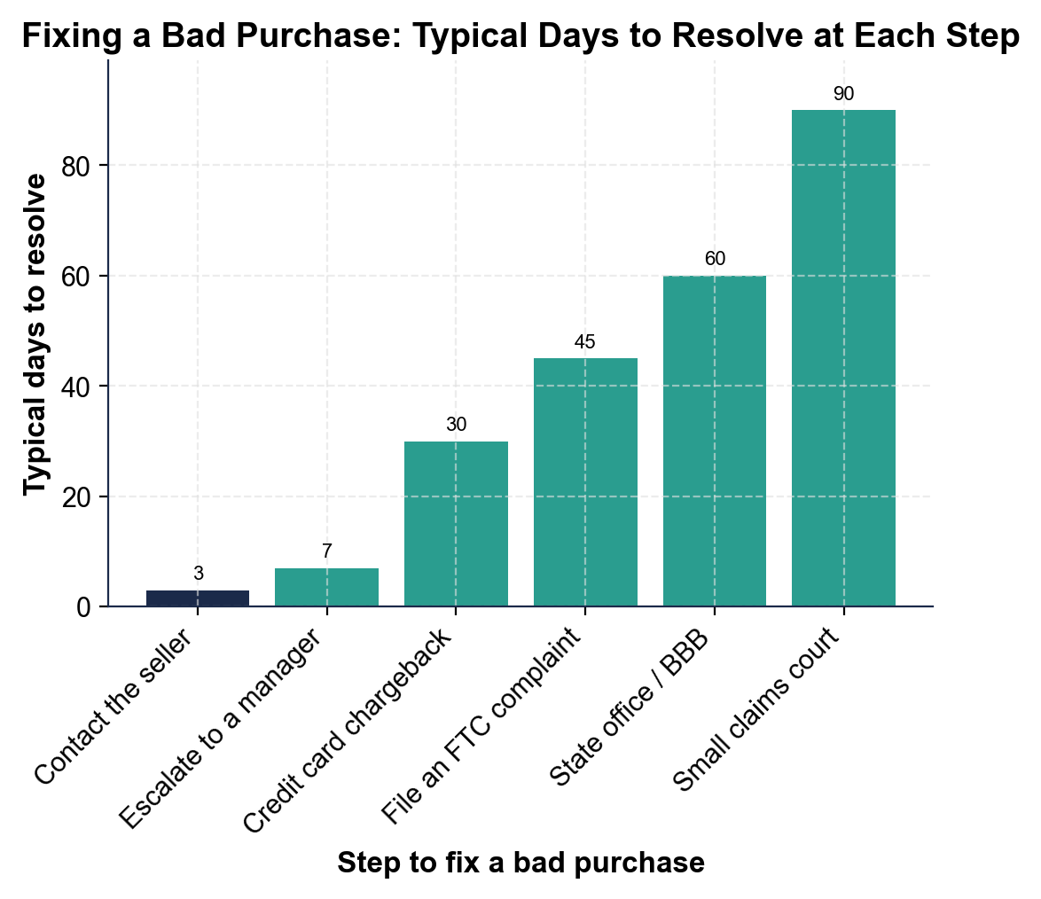
(a) Contact the seller: 3 days. (b) Escalate to a manager: 7 days. (c) Credit card chargeback: 30 days. (d) File an FTC complaint: 45 days. (e) State office / BBB: 60 days. (f) Small claims court: 90 days. Accept these six values (in days) read directly off the bars.

2. A4-Q2. As Marcus Reed, use the chart to compare the steps. (a) Which step is the FASTEST way to fix a bad purchase, and about how many days does it take? (b) Which is the SLOWEST, and about how many days? (c) How many MORE days does the slowest step take than the fastest one? Show your math.
(1) FASTEST = CONTACT THE SELLER, about 3 days (the shortest bar) - which is exactly why it is rung 1. (2) SLOWEST = SMALL CLAIMS COURT, about 90 days (the tallest bar) - which is why it is the last resort. (3) Difference = 90 - 3 = 87 more days for small claims court than for contacting the seller. Accept contact the seller (3) as fastest, small claims court (90) as slowest, and a difference of 87.

3. A4-Q3. As Marcus Reed, keep comparing the bars. (a) Small claims court takes about 90 days and a chargeback about 30 - how many TIMES as long does small claims court take? Show your math. (b) What are the TWO fastest steps, and what does that tell a shopper about where to start?
(1) 90 / 30 = 3, so small claims court takes 3 times (3x) as long as a chargeback. (2) The two fastest steps are CONTACT THE SELLER (3 days) and ESCALATE TO A MANAGER (7 days), so a shopper should almost always START at the bottom of the ladder with the seller and only climb higher if those quick steps do not fix it. Accept 3x for part (a) and contact the seller + escalate to a manager as the two fastest for part (b).

4. A4-Q4. As Marcus Reed, turn the chart into advice. (a) What pattern do you see across the six bars as you move up the ladder? (b) A shopper wants to skip straight to small claims court over a $40 problem - use the chart to explain why that is usually a bad idea. (c) In one sentence, what is your rule for which step to try first?
(1) The pattern: the bars RISE as you climb the ladder - each step up takes more days (from 3 for the seller to 90 for small claims court) - so every rung up costs more time. (2) Skipping to small claims court over $40 is a bad idea because the chart shows court takes about 90 days versus about 3 days to contact the seller - you would spend three months and a filing fee on a small problem a quick message or a 30-day chargeback would likely fix. (3) Rule: always START at the bottom of the ladder (contact the seller) and climb one rung at a time, escalating only if the step below does not fix it. Accept a rising/increasing pattern, a 'court is far slower for a small amount' explanation, and a start-low / escalate-only-if-needed rule.

PART 5

Dispute a Bad Purchase - Name the Right Step
1. STEP #1. As Marcus Reed, name the right step. A shopper's online order never arrived. They have not contacted anyone yet. What is the RIGHT FIRST step?
RUNG 1 - CONTACT THE SELLER. Message the seller with the order number, say the package never arrived, and ask for a refund or a replacement - most missing-package problems are fixed at this first step.
2. STEP #2. A shopper bought a defective blender that stopped working after two weeks. It came with a one-year warranty, and the store said no to a refund. What is the right step to get a free repair or replacement?
Use the WARRANTY (escalate the claim): the one-year warranty is a promise to repair or replace a product that breaks in a set time, so the shopper files a warranty claim with the manufacturer or asks a manager to honor it - rung 2, escalating past the front-line 'no.' Accept…
3. STEP #3. A shopper paid by credit card for a laptop that arrived cracked. They emailed the seller twice with photos and were ignored. What is the right step now?
RUNG 3 - A CHARGEBACK. Because they contacted the seller and were ignored and paid by credit card, they call the card company to dispute the charge for a defective item and ask for the money to be reversed.
4. STEP #4. A shopper discovers a website that took their money, shipped nothing, and appears to be scamming lots of people. Their own chargeback already refunded them, but they want to help stop the scammer. What step protects the next shopper?
FILE AN FTC COMPLAINT (rung 4): report the scam for free at ReportFraud.ftc.gov with the proof. The FTC may not refund each person, but the report helps build a case against a repeat bad actor and protects the next shopper.
5. STEP #5. A shopper bought a shirt three days ago, still with tags and the receipt, and it does not fit. The store's sign says 30-day returns. What is the right step?
RUNG 1 - CONTACT THE SELLER / RETURN IT. The item is inside the return window, unused, with tags and receipt, so the shopper simply returns it under the store's return policy for a refund or exchange.
6. STEP #6. A shopper contacted the seller, escalated to a manager, filed a chargeback (it was denied), and filed an FTC complaint - and still has no refund for a $900 item that was never delivered. What is the last-resort step?
RUNG 6 - SMALL CLAIMS COURT. Every lower rung has failed and $900 is large enough to be worth the time, so the last resort is to file in small claims court, pay the small fee, and bring the proof to a judge - no lawyer needed.
7. STEP #7. A shopper is about to buy a $600 phone from an online seller they have never used before. They ask you how to PROTECT themselves before anything goes wrong. What do you advise?
PAY BY CREDIT CARD and keep your proof. A credit card gives chargeback protection that cash and debit often do not, so if the phone never arrives or is fake, the shopper can dispute the charge - and saving the order confirmation and messages gives them the proof that wins a…
8. STEP #8. A shopper's package arrived exactly as described, on time, and works perfectly - but two days later they simply changed their mind and want to return it. What is the right step, and what right do they have?
RETURN IT UNDER THE RETURN POLICY (rung 1) - IF the policy allows it. A change-of-mind return is not a defect, so there is no automatic right to a refund; the shopper is limited to the store's return policy (window, condition, receipt).
CONSUMER-ADVOCATE ACTION PLAN - FINAL REPORT
9. CONSUMER-ADVOCATE ACTION PLAN - FINAL REPORT. As Marcus Reed, write a short guide a shopper could follow when a purchase goes wrong. Write 5-7 sentences (100-160 words) that:
(a) name the first thing to do and the proof to keep
(b) explain the escalation ladder and how to climb it
(c) name which heavier tool matches which problem (a chargeback, an FTC complaint, and small claims court). Check off each required element as you include it.
Sample full-credit action plan: When a purchase goes wrong, know your CONSUMER RIGHTS and start at the bottom of the ESCALATION LADDER.
MORE LESSONS LESS PLANNING
Thank You!
If you enjoyed this product, please do not forget to rate and review to assist other teachers.

Looking for future discounts? Earn TPT credits by reviewing purchased products.

Please contact me if you have any issues with this product. Just like our students, I am always looking for opportunities to grow.

