Consumer Confidence: Why It Predicts the Future
STUDENT ACTIVITY
Name: | Date: | Period:
ESSENTIAL QUESTION
Can a survey of how households FEEL about the economy really predict what they will DO - and what is consumer confidence signaling about where the economy is headed?
THE SCENARIO
You are a CONSUMER ANALYST on Diana Lopez's team at Meridian Capital, a mid-sized investment firm. Diana needs a read on what consumer confidence is signaling right now.
BY THE END, YOU CAN:
✓ Define consumer confidence and explain why it predicts spending
✓ Distinguish the Conference Board and University of Michigan indexes
✓ Evaluate consumer sentiment as a real-time indicator of where the economy is going
HOW IT WORKS (do Parts 1–5 in order)
Part 1 — Consumer Confidence Reference Guide - Complete the Missing Terms
Part 2 — Apply the Terms - Confirm the Consumer-Confidence Vocabulary
Part 3 — Read the Consumer Confidence Index Chart and Diagnose the 2022 Collapse
Part 4 — Read the Confidence vs Retail Sales Scatter and the Fed Connection
Part 5 — Final Recommendation Memo to the Retail-Stock Client
TIME about 45 minutes YOU’LL NEED the lesson slides and your Guided Notes.

PART 1

Consumer Confidence Reference Guide - Complete the Missing Terms
Fill in the missing term for each blank row — the definition is your clue. Your Guided Notes and the lesson slides have every term.

Term | Definition
___________ | A survey-based measure of how households feel about the economy now and where they expect it to go over the next 6 to 12 months.
Conference Board CCI | The Conference Board index, baseline 1985 = 100, based on a monthly survey of about 3,000 U.S. households, published the last Tuesday of each month.
___________ | A measure that moves before the rest of the economy; confidence moves first and the hard data follows about 3 to 6 months later.
University of Michigan ICS | The University of Michigan Index of Consumer Sentiment, baseline 1966, based on a monthly telephone survey of about 600 U.S. households; the longest-running series.
___________ | What households expect inflation to be over the next year, tracked monthly by the Michigan survey; a key input to Federal Reserve policy.
Sentiment | Another word for how people feel about the economy, their jobs, and their finances; what the confidence surveys are built to measure.
___________ | Survey-based measures of how people feel about the economy, different from hard data like GDP and retail sales (actual measured activity).
Retail sales | Monthly U.S. household spending that confidence predicts about 3 to 6 months later; other factors like Fed rates, oil prices, and wages also drive it.
___________ | About 70% of U.S. GDP, so how households feel about the economy matters because their spending makes up most of it.
Hard data | Real economic numbers like GDP, retail sales, and employment; more reliable than feelings because they measure what people actually do.

PART 2

Apply the Terms - Confirm the Consumer-Confidence Vocabulary
WORD BANK leading indicator · consumer spending · inflation expectations · soft data · consumer confidence
1. Q1. A survey-based measure of how households feel about the economy now and where they expect it to go over the next 6-12 months is .

2. Q2. Because confidence tends to move about 3-6 months before the rest of the economy - it moves first, and spending follows - economists call it a .

3. Q3. What households tell the Michigan survey they think prices will do over the next year - a number the Federal Reserve watches closely - is called .

4. Q4. Survey-based feelings about the economy - the opposite of measured numbers like GDP - are an example of .

5. Q5. The roughly 70% of U.S. GDP that comes from households buying goods and services - the biggest single driver of the economy - is .

PART 3

Read the Consumer Confidence Index Chart and Diagnose the 2022 Collapse
1. As Diana's consumer analyst, study the CONSUMER CONFIDENCE INDEX chart inserted below (the Conference Board CCI plotted for each year, 2000-2026). Reading directly off the chart:
(a) about what was the ALL-TIME LOW value, and in what year?

(b) about what was the PRE-PANDEMIC PEAK value, and in what year(s)?

(c) about how far did the CCI dip during the 2020 COVID shock, and how is that visible on the line?

(d) about what was the CCI value by 2024 (the partial recovery)? Use specific numbers. (Chart: chart_cci_2000_2026)
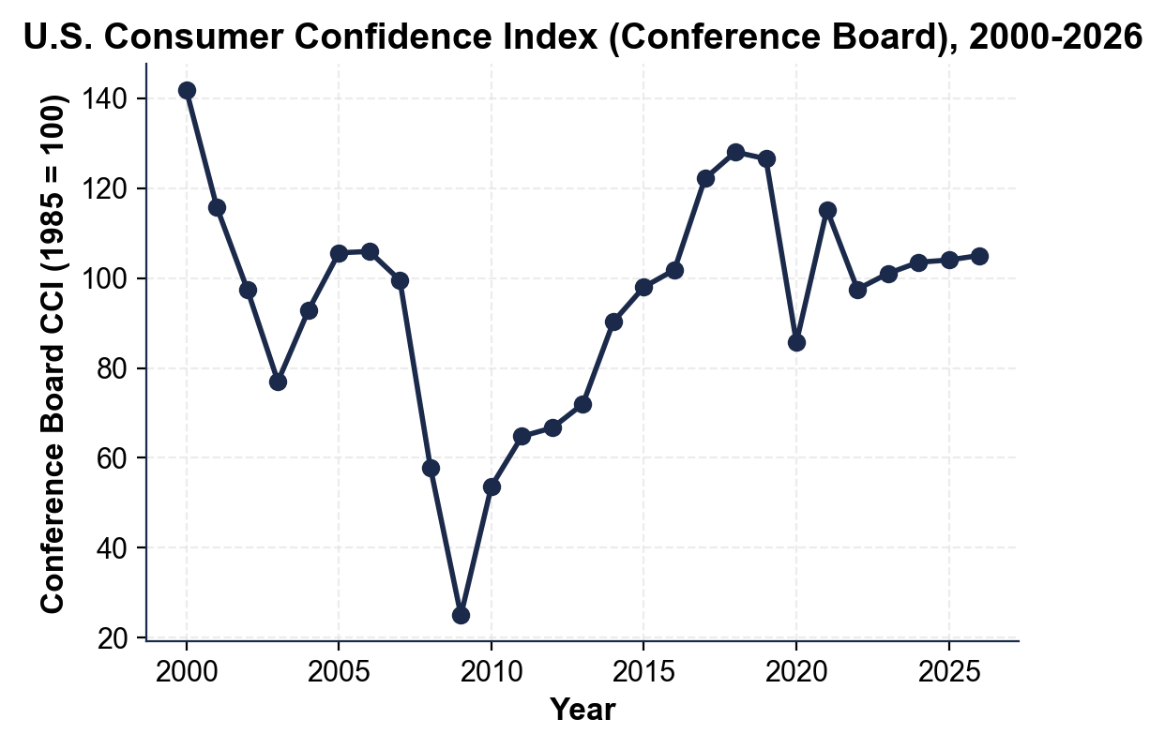

2. As Diana's analyst, explain why the 2022 confidence collapse was UNUSUAL in 4-5 sentences:
(a) the University of Michigan ICS hit its all-time low in June 2022 - state that reading and put it in historical context (how does it compare to 2008, 2020, and 1980?)

(b) identify what CAUSED the collapse (cite the specific inflation rate)

(c) explain why the Conference Board CCI held up BETTER than the Michigan ICS in 2022

(d) explain why retail sales did NOT collapse despite the confidence drop.

PART 4

Read the Confidence vs Retail Sales Scatter and the Fed Connection
1. As Diana's analyst, study the CONFIDENCE vs RETAIL SALES SCATTER PLOT inserted below. Each dot is one YEAR (2000-2024): the x-axis is the Conference Board CCI; the y-axis is the U.S. retail sales year-over-year change SIX MONTHS LATER. Reading directly off the chart:
(a) is the slope UPWARD or DOWNWARD - and what does that direction mean about the relationship between confidence and future retail sales?

(b) what do the LOWER-LEFT dots (low CCI paired with negative retail sales 6 months later) represent - identify the era.

(c) what do the UPPER-RIGHT dots (high CCI paired with solid retail sales 6 months later) represent - identify the era.

(d) is the fit loose, moderate, or tight - and name ONE outlier dot that does NOT follow the trend? (Chart: chart_confidence_vs_retail_sales)
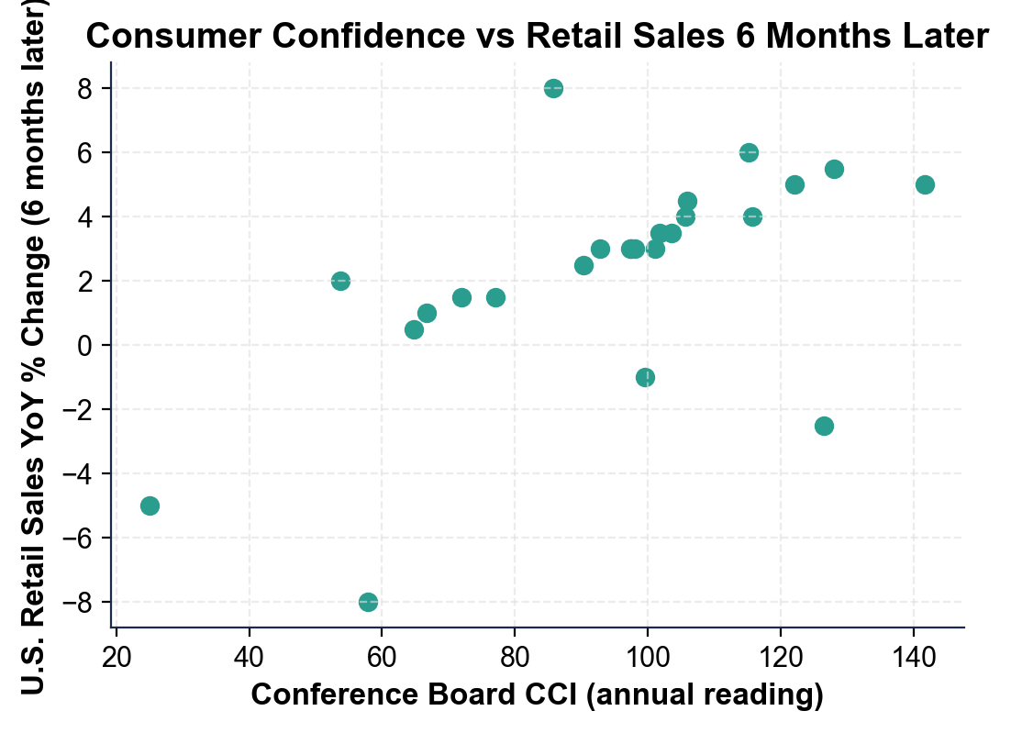

2. APPLY THE FED CONNECTION. Diana wants a quick read on WHY the Federal Reserve watches the Michigan inflation expectations component every month. Answer in 2-3 sentences. Reference
(a) what specifically the Michigan survey asks households about inflation

(b) what the Fed worries about if expectations rise above 3-4%

(c) the specific Fed action that 2022 expectations triggered.

PART 5

Final Recommendation Memo to the Retail-Stock Client
FINAL RECOMMENDATION MEMO
1. FINAL RECOMMENDATION MEMO. Diana's client is a portfolio manager at a large retail-focused investment firm. Write a 6-8 sentence recommendation memo using the header below, and check off each required element as you include it. For current readings, use the most recent Conference Board CCI level from your Part 3 chart reading (the right-hand end of the line), plus these additional facts from your firm's data feed: the Michigan ICS is about 67-70 (recovered from its 2022 record low but still below its pre-pandemic norm near 100), inflation expectations are back to about 3%, real wage growth is slightly positive, and unemployment is about 4.0%. (Sentence starters you can use: "Consumer sentiment is currently in a..." and "I recommend...")
YOUR RESPONSE MUST:
☐ CURRENT STATE - summarize where consumer sentiment stands now using BOTH indexes (the CCI level you read at the right end of the Part 3 chart and the Michigan ICS level from the data feed above) compared to their historical norms (the pre-pandemic peaks and the 2022 lows).
☐ WHAT IT SIGNALS - interpret what those readings mean for retail sales 3-6 months ahead, using the leading-indicator logic from the lesson (is a sharp drop or a boom likely, or something in between?).
☐ A CLEAR RECOMMENDATION - recommend INCREASING, DECREASING, or HOLDING retail-stock exposure, and justify it with at least TWO specific facts from the data (e.g., inflation expectations near 3%, real wages positive, unemployment 4.0%, or the indexes sitting below their pre-pandemic peaks).
MEMO
To: Portfolio Manager, Retail-Focused Investment Firm
From: Consumer Analyst, Meridian Capital
Date:
Re: Consumer Confidence Read and Retail-Stock Recommendation

