ECONOMICS

CONSUMER CONFIDENCE: WHY IT PREDICTS THE FUTURE
ANSWER KEY ACTIVITY - ANSWER KEY

PART 1

Consumer Confidence Reference Guide - Complete the Missing Terms

Term | Definition
Consumer confidence | A survey-based measure of how households feel about the economy now and where they expect it to go over the next 6 to 12 months.
Conference Board CCI | The Conference Board index, baseline 1985 = 100, based on a monthly survey of about 3,000 U.S. households, published the last Tuesday of each month.
Leading indicator | A measure that moves before the rest of the economy; confidence moves first and the hard data follows about 3 to 6 months later.
University of Michigan ICS | The University of Michigan Index of Consumer Sentiment, baseline 1966, based on a monthly telephone survey of about 600 U.S. households; the longest-running series.
Inflation expectations | What households expect inflation to be over the next year, tracked monthly by the Michigan survey; a key input to Federal Reserve policy.
Sentiment | Another word for how people feel about the economy, their jobs, and their finances; what the confidence surveys are built to measure.
Soft data | Survey-based measures of how people feel about the economy, different from hard data like GDP and retail sales (actual measured activity).
Retail sales | Monthly U.S. household spending that confidence predicts about 3 to 6 months later; other factors like Fed rates, oil prices, and wages also drive it.
Consumer spending | About 70% of U.S. GDP, so how households feel about the economy matters because their spending makes up most of it.
Hard data | Real economic numbers like GDP, retail sales, and employment; more reliable than feelings because they measure what people actually do.

PART 2

Apply the Terms - Confirm the Consumer-Confidence Vocabulary
WORD BANK leading indicator · consumer spending · inflation expectations · soft data · consumer confidence
1. Q1. A survey-based measure of how households feel about the economy now and where they expect it to go over the next 6-12 months is Consumer confidence.
Consumer confidence
2. Q2. Because confidence tends to move about 3-6 months before the rest of the economy - it moves first, and spending follows - economists call it a Leading indicator.
Leading indicator
3. Q3. What households tell the Michigan survey they think prices will do over the next year - a number the Federal Reserve watches closely - is called Inflation expectations.
Inflation expectations
4. Q4. Survey-based feelings about the economy - the opposite of measured numbers like GDP - are an example of Soft data.
Soft data
5. Q5. The roughly 70% of U.S. GDP that comes from households buying goods and services - the biggest single driver of the economy - is Consumer spending.
Consumer spending
PART 3

Read the Consumer Confidence Index Chart and Diagnose the 2022 Collapse
1. As Diana's consumer analyst, study the CONSUMER CONFIDENCE INDEX chart inserted below (the Conference Board CCI plotted for each year, 2000-2026). Reading directly off the chart:
(a) about what was the ALL-TIME LOW value, and in what year?
(b) about what was the PRE-PANDEMIC PEAK value, and in what year(s)?
(c) about how far did the CCI dip during the 2020 COVID shock, and how is that visible on the line?
(d) about what was the CCI value by 2024 (the partial recovery)? Use specific numbers. (Chart: chart_cci_2000_2026)
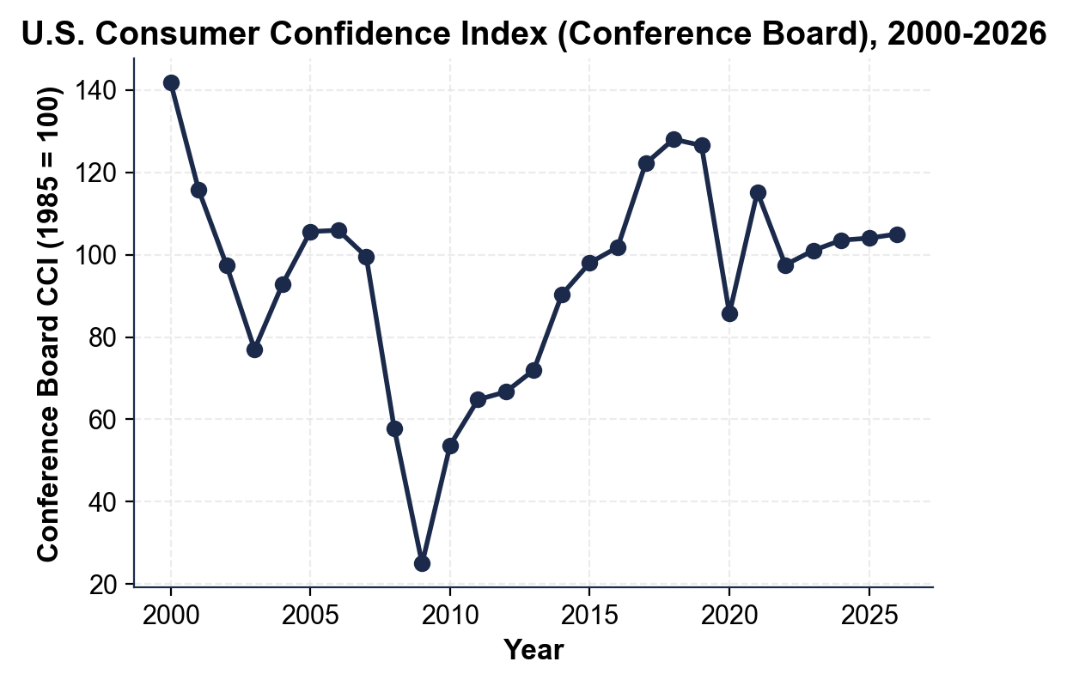
ALL-TIME LOW: about 25 in 2009 (the Great Recession trough; the all-time low in the Conference Board series). PRE-PANDEMIC PEAK: about 128-130 in 2018-2019 (the long pre-pandemic expansion). 2020 COVID DIP: the line drops sharply to about 86 in 2020 (a brief V-shaped dip from the 2019 peak near 127, then a fast rebound to about 115 in 2021). 2024 RECOVERY: about 100-105 (the partial recovery from the 2022 inflation-crisis dip to about 97, still BELOW the 2018-2019 peak). REQUIRED: identifies 2009 trough ~25; 2018-2019 peak ~128-130; 2020 COVID dip ~86; 2024 ~100-105.
2. As Diana's analyst, explain why the 2022 confidence collapse was UNUSUAL in 4-5 sentences:
(a) the University of Michigan ICS hit its all-time low in June 2022 - state that reading and put it in historical context (how does it compare to 2008, 2020, and 1980?)
(b) identify what CAUSED the collapse (cite the specific inflation rate)
(c) explain why the Conference Board CCI held up BETTER than the Michigan ICS in 2022
(d) explain why retail sales did NOT collapse despite the confidence drop.
MICHIGAN LOW: the University of Michigan ICS hit 50.0 in June 2022 - the all-time low in the entire 76-year history of the series, LOWER than the 2008 trough (~55), the 2020 COVID trough (~71), and even the 1980 stagflation trough (~51.7). THE CAUSE: inflation - CPI hit 9.1% in June 2022, a 40-year high, with gas above $5/gallon and Michigan inflation expectations at 5.4%. WHY THE CONFERENCE BOARD HELD UP: the Conference Board emphasizes JOBS and business conditions, and unemployment was a historic-low 3.6% in 2022, so the CCI fell only to about 95 - nowhere near its all-time low of 25; Michigan emphasizes household finances and PRICES, so the inflation shock hit it harder. WHY RETAIL SALES DID NOT COLLAPSE: jobs stayed strong and nominal wages were rising, so households felt terrible but still had money and kept spending - the divergence between sentiment and behavior. REQUIRED: Michigan 50.0 all-time low; 9.1% inflation cause; Conference Board held up because of strong jobs; the sentiment-vs-spending divergence.
PART 4

Read the Confidence vs Retail Sales Scatter and the Fed Connection
1. As Diana's analyst, study the CONFIDENCE vs RETAIL SALES SCATTER PLOT inserted below. Each dot is one YEAR (2000-2024): the x-axis is the Conference Board CCI; the y-axis is the U.S. retail sales year-over-year change SIX MONTHS LATER. Reading directly off the chart:
(a) is the slope UPWARD or DOWNWARD - and what does that direction mean about the relationship between confidence and future retail sales?
(b) what do the LOWER-LEFT dots (low CCI paired with negative retail sales 6 months later) represent - identify the era.
(c) what do the UPPER-RIGHT dots (high CCI paired with solid retail sales 6 months later) represent - identify the era.
(d) is the fit loose, moderate, or tight - and name ONE outlier dot that does NOT follow the trend? (Chart: chart_confidence_vs_retail_sales)
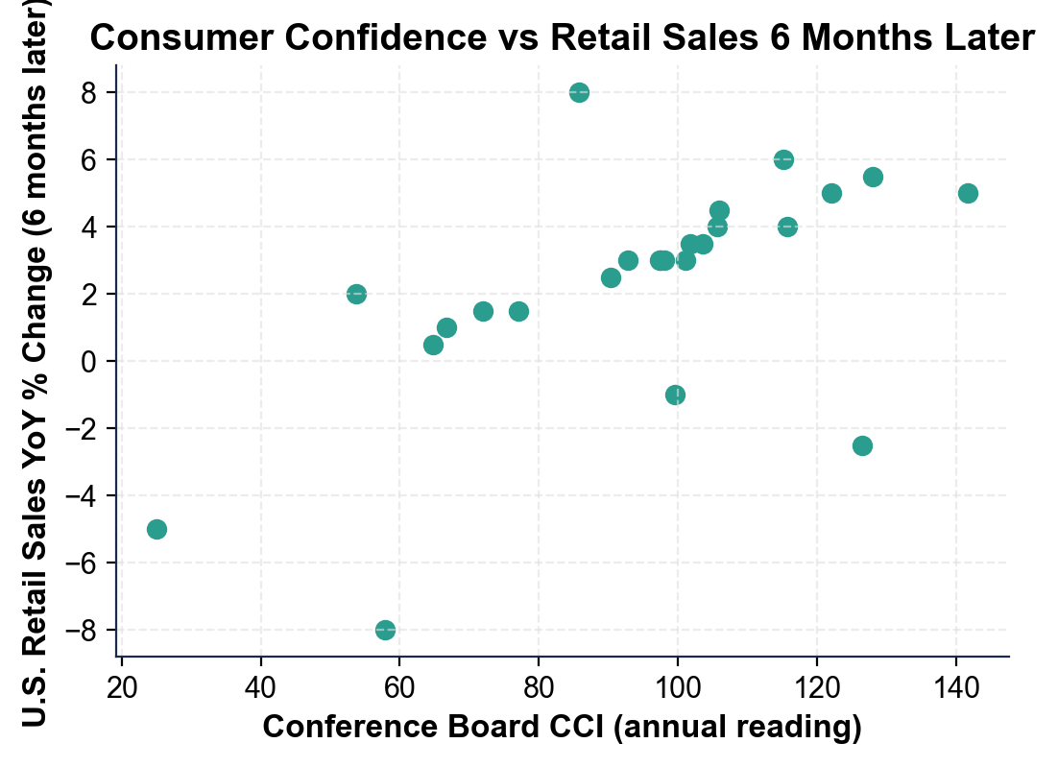
SLOPE: UPWARD (moderate positive correlation) - higher consumer confidence in one year tends to predict FASTER retail sales growth six months later, so sentiment IS a (loose) leading indicator. LOWER-LEFT DOTS: low CCI (below 60) paired with NEGATIVE retail sales six months later - the 2008 (about -8%) and 2009 (about -5%) GREAT RECESSION years. UPPER-RIGHT DOTS: high CCI (above 120) paired with solid retail growth of about 5% - the 2000, 2017, and 2018 EXPANSION years. THE FIT: MODERATE and LOOSE - about r = 0.5 to 0.6; meaningful but not tight because of outliers like 2020 (CCI about 86 but retail surged about +8% later on pandemic stimulus) and 2019 (high CCI about 127 but retail fell about -2.5% later because COVID hit). REQUIRED: upward slope = positive correlation; lower-left = 2008-2009 recession (negative retail); upper-right = 2017-2018 expansion (about 5%); moderate/loose fit with at least one named outlier (2020 stimulus or 2019 COVID).
2. APPLY THE FED CONNECTION. Diana wants a quick read on WHY the Federal Reserve watches the Michigan inflation expectations component every month. Answer in 2-3 sentences. Reference
(a) what specifically the Michigan survey asks households about inflation
(b) what the Fed worries about if expectations rise above 3-4%
(c) the specific Fed action that 2022 expectations triggered.
WHAT MICHIGAN ASKS: the Michigan survey asks households what they EXPECT inflation to be over the next year; actual inflation depends partly on what people expect, a self-fulfilling feedback loop. THE FED WORRY: if expectations rise above 3-4%, the Fed worries inflation could become ANCHORED high - if households expect 5% inflation, they demand 5% raises and businesses set 5% price increases, and 5% inflation becomes permanent; the Fed must break the loop. THE 2022 ACTION: Michigan inflation expectations rose to 5.4% (a 40-year high), and Fed Chair Powell explicitly cited rising expectations to justify the 0% to 5.25% rate-hiking cycle in 2022-2023, which pushed expectations back to about 3% by 2024. REQUIRED: Michigan asks about expected inflation; explains anchored expectations / the feedback loop; cites the 5.4% reading and the 0% to 5.25% Fed hikes.
PART 5

Final Recommendation Memo to the Retail-Stock Client
FINAL RECOMMENDATION MEMO
1. FINAL RECOMMENDATION MEMO. Diana's client is a portfolio manager at a large retail-focused investment firm. Write a 6-8 sentence recommendation memo using the header below, and check off each required element as you include it. For current readings, use the most recent Conference Board CCI level from your Part 3 chart reading (the right-hand end of the line), plus these additional facts from your firm's data feed: the Michigan ICS is about 67-70 (recovered from its 2022 record low but still below its pre-pandemic norm near 100), inflation expectations are back to about 3%, real wage growth is slightly positive, and unemployment is about 4.0%. (Sentence starters you can use: "Consumer sentiment is currently in a..." and "I recommend...")
YOUR RESPONSE MUST:
☐ CURRENT STATE - summarize where consumer sentiment stands now using BOTH indexes (the CCI level you read at the right end of the Part 3 chart and the Michigan ICS level from the data feed above) compared to their historical norms (the pre-pandemic peaks and the 2022 lows).
☐ WHAT IT SIGNALS - interpret what those readings mean for retail sales 3-6 months ahead, using the leading-indicator logic from the lesson (is a sharp drop or a boom likely, or something in between?).
☐ A CLEAR RECOMMENDATION - recommend INCREASING, DECREASING, or HOLDING retail-stock exposure, and justify it with at least TWO specific facts from the data (e.g., inflation expectations near 3%, real wages positive, unemployment 4.0%, or the indexes sitting below their pre-pandemic peaks).
MEMO
To: Portfolio Manager, Retail-Focused Investment Firm
From: Consumer Analyst, Meridian Capital
Date: [student completes]
Re: Consumer Confidence Read and Retail-Stock Recommendation
GRADING RUBRIC
Grade the evidence and reasoning, not the conclusion — any defensible position is valid. Score against the 3 requirements above.
FULL CREDIT — clear position; meets all 3 requirements with accurate, specific numbers and evidence from the lesson.
PARTIAL — position stated, but misses 1-2 requirements or uses vague / incorrect numbers.
MINIMAL — no clear position, or missing most requirements and numbers.

MORE LESSONS LESS PLANNING
Thank You!
If you enjoyed this product, please do not forget to rate and review to assist other teachers.

Looking for future discounts? Earn TPT credits by reviewing purchased products.

Please contact me if you have any issues with this product. Just like our students, I am always looking for opportunities to grow.

