Cartels and Collusion - How OPEC Controls Oil
STUDENT ACTIVITY
Name: | Date: | Period:
ESSENTIAL QUESTION
If everyone agrees to keep prices high, why does someone always cheat?
THE SCENARIO
You report for a paid summer internship at the U.S. Energy Information Administration (EIA) and you are assigned to MEERA AGARWAL's cartel and market structures team. Meera's job is studying OPEC - the most famous cartel in the world - and figuring out what U.S. policy should do about it.
BY THE END, YOU CAN:
✓ Identify what a CARTEL is (a formal agreement among competing producers to limit output and raise prices), name OPEC's founding year (1960), headquarters (Vienna), and current size (12 members controlling about 37% of global crude oil)
✓ Define CARTEL, PRODUCTION QUOTA, CARTEL CHEATING, COLLUSION (explicit vs tacit), OPEC+, SWING PRODUCER, and STRATEGIC PETROLEUM RESERVE and explain why cartels are inherently unstable
✓ Read three real charts (OPEC's 1960-2024 global market share, OPEC member quota vs actual production in 2024, and oil prices at seven major OPEC events) and write a Final Briefing Memo recommending what the U.S. should do about OPEC's market power
HOW IT WORKS (do Parts 1–5 in order)
Part 1 — OPEC and Cartels Reference Guide - Complete the Missing Terms
Part 2 — Apply the Terms - OPEC and Cartels Vocabulary in Context
Part 3 — You Read the Three OPEC Charts with Meera Agarwal at the EIA
Part 4 — Four Real Scenarios with Meera Agarwal - Apply the Model
Part 5 — Your Final Briefing Memo to Meera Agarwal
TIME about 45 minutes YOU’LL NEED the lesson slides and your Guided Notes.

PART 1

OPEC and Cartels Reference Guide - Complete the Missing Terms
Fill in the missing term for each blank row — the definition is your clue. Your Guided Notes and the lesson slides have every term.

Term | Definition
___________ | A formal agreement among competing producers to limit total output, set production quotas for each member, and raise the market price above the competitive level - OPEC is the most famous example in the world
OPEC | The Organization of the Petroleum Exporting Countries - a cartel founded in Baghdad in 1960 and headquartered in Vienna, Austria; currently 12 member nations producing about 37% of global crude oil
___________ | Each cartel member's assigned maximum daily output set by the cartel agreement - OPEC quotas are negotiated at twice-yearly ministerial meetings and measured in millions of barrels per day
Cartel cheating | When an individual cartel member produces ABOVE its assigned quota to capture extra revenue at the cartel's expense - the central reason cartels are inherently unstable and tend to collapse
___________ | Any coordination among competitors to fix prices, divide markets, or restrict output - the broader category that contains cartels; can be EXPLICIT (formal agreement like OPEC) or TACIT (silent price-matching)
Sherman Antitrust Act | The 1890 U.S. federal law that makes most cartels ILLEGAL within the United States; this is why OPEC operates from Vienna and not from U.S. soil, and why no U.S. companies can join
___________ | The expanded coordination group formed in 2016 when Russia and nine other non-OPEC oil producers joined OPEC's production decisions; OPEC+ controls about 48% of global oil supply combined
1973 oil embargo | The first major OPEC action - Arab members halted oil exports to the U.S. over Yom Kippur War support for Israel; oil prices tripled and triggered Western stagflation
___________ | The cartel member that adjusts its output UP or DOWN to balance the market when other members cheat - Saudi Arabia plays this role in OPEC because it has the largest reserves and the lowest production costs
Strategic Petroleum Reserve | The U.S. emergency oil stockpile Congress created in 1975 after the 1973 OPEC embargo; the SPR can be released to counter OPEC supply cuts

PART 2

Apply the Terms - OPEC and Cartels Vocabulary in Context
WORD BANK OPEC+ · collusion · cartel · swing producer · production quota
1. Meera asks you to write the opening definition for the memo. A formal agreement among competing producers to limit total output and raise the market price above the competitive level is called a .

2. The next term Meera needs is the limit each OPEC member agrees to. Each cartel member is assigned a maximum daily output, negotiated at twice-yearly Vienna meetings and measured in millions of barrels per day - this assigned ceiling is the member's .

3. Meera explains that a cartel is just one type of a broader behavior. Any coordination among competitors to fix prices, divide markets, or restrict output - the broad category that contains cartels and can be either explicit or tacit - is called .

4. Meera points to the 2016 expansion. The coordination group formed when Russia and nine other non-OPEC producers joined OPEC production decisions, controlling about 48 percent of global oil supply combined, is called .

5. Finally Meera asks about the member that keeps the cartel alive. The cartel member that adjusts its output up or down to balance the market when others cheat - the role Saudi Arabia plays because it has the largest reserves and lowest production costs - is called the .

PART 3

You Read the Three OPEC Charts with Meera Agarwal at the EIA
1. Use Chart Reference 1 (chart_opec_global_share) - the bar chart showing OPEC's share of global crude oil production in 1960, 1973, 1985, 2000, 2016, and 2024 shown below - to evaluate OPEC's long-run market power.
(a) Read the six percentages off the chart.

(b) Calculate the share drop from the 1973 peak to the 1985 low.

(c) Identify which decade saw the LARGEST decline.

(d) In 1-2 sentences, explain why OPEC's share has NEVER returned to its 1973 peak even after 50 years.

2. Use Chart Reference 2 (chart_opec_quota_vs_actual) - the grouped bar chart showing each major OPEC member's quota and actual daily production (millions of barrels per day) in 2024 shown below - to identify the cartel cheating pattern.
(a) Read each country's quota and actual production.

(b) Identify which members are CHEATING (producing ABOVE quota).

(c) Identify which member is the SWING PRODUCER (cutting BELOW quota to absorb the cheating) and calculate how much it is cutting.

(d) In 1-2 sentences, explain why the cartel only stays together because Saudi Arabia is willing to take the losses.

3. Use Chart Reference 3 (chart_oil_price_opec_events) - the bar chart showing the average Brent crude oil price (USD per barrel) in the year of seven major OPEC events shown below - to evaluate OPEC's historical pricing power.
(a) Read all seven price points.

(b) Identify the multiplier on the 1972-to-1974 embargo jump (price ratio).

(c) Identify what happened in 1986 (the Saudi flood collapse) and what the 1986 price level shows about cartel discipline.

(d) In 1-2 sentences, predict whether OPEC can sustain $90+ prices long term given that U.S. shale survived two Saudi price wars (1985 and 2014).

PART 4

Four Real Scenarios with Meera Agarwal - Apply the Model
1. THE CHEATING INCENTIVE QUESTION. Meera hands you a 2024 OPEC compliance memo: 8 of the 12 members produced above their assigned quotas at some point during the year. Meera asks: why does this keep happening?
(a) Walk through the basic economic logic of the cheating incentive (use the $40-to-$80 example from Part 1).

(b) Identify ONE specific OPEC member that chronically cheats and explain its motivation (Iraq is the clearest case - explain why).

(c) Argue whether OPEC can ever SOLVE the cheating problem internally.

(d) Identify ONE specific structural reform OPEC could adopt that would reduce cheating - and explain why members would resist it.

2. THE SAUDI SWING PRODUCER DILEMMA. The Saudi swing producer role keeps OPEC alive but costs Saudi Arabia roughly $30 billion per year in foregone revenue (cutting 1 mbd at $80/barrel for 365 days = $29.2 billion). Meera asks: why does Saudi Arabia keep doing this?
(a) Identify TWO specific economic reasons Saudi Arabia accepts the swing producer cost.

(b) Identify ONE specific political reason Saudi Arabia accepts the cost.

(c) Argue under what conditions Saudi Arabia might ABANDON the swing producer role again (like 1985 and 2014).

(d) Predict what would happen to OPEC if Saudi Arabia permanently quit the swing producer role.

3. THE OPEC+ RUSSIA QUESTION. OPEC+ was formed in December 2016 by adding Russia and 9 other non-OPEC producers to OPEC's production decisions. Meera asks: was this a smart move?
(a) Identify ONE specific reason OPEC needed Russia after the 2014-2016 shale war.

(b) Identify ONE specific risk OPEC took by adding Russia.

(c) Argue whether OPEC+ has been more or less stable than the old OPEC-only structure.

(d) Argue whether Russia's 2022 invasion of Ukraine STRENGTHENED or WEAKENED OPEC+ - and explain your reasoning.

4. THE U.S. POLICY CHOICE. Meera asks: what should the U.S. do about OPEC's market power? She gives you four options to evaluate.
(a) Make the case for OPTION 1 - INCREASE DOMESTIC SHALE PRODUCTION (lease more federal land, accelerate permitting, push U.S. production from 13 to 16 mbd).

(b) Make the case for OPTION 2 - RELEASE THE STRATEGIC PETROLEUM RESERVE more aggressively to counter OPEC supply cuts.

(c) Make the case for OPTION 3 - ACCELERATE THE ELECTRIC VEHICLE TRANSITION to reduce oil demand.

(d) Make the case for OPTION 4 - COORDINATE WITH OTHER CONSUMER NATIONS (EU, Japan, India, China) to push back against OPEC pricing. Pick one and explain.

PART 5

Your Final Briefing Memo to Meera Agarwal
EIA OPEC POLICY RECOMMENDATION MEMO
1. Meera closes the assignment.
A state senator wants the EIA to recommend what the United States should do about OPEC market power over the next 5 to 10 years, and Meera is handing the draft to you. Using your work from Parts 1 through 4, and using all four required terms (cartel, production quota, cartel cheating, swing producer) at least once each, what is your final 6 to 8 sentence briefing memo recommending what U.S. policy should do about OPEC market power?
YOUR RESPONSE MUST:
☐ Names a SPECIFIC U.S. POLICY OPTION (increase shale production, release SPR, accelerate EV transition, or coordinate consumer nations) AND ties the choice to the nature of OPEC market power.
☐ Uses the term CARTEL correctly - identifies OPEC as a formal agreement among competing producers to limit output and raise prices.
☐ Uses the term PRODUCTION QUOTA correctly - identifies it as each OPEC member's assigned maximum daily output.
☐ Uses the term CARTEL CHEATING correctly - identifies it as the structural reason OPEC is inherently unstable.
☐ Uses the term SWING PRODUCER correctly - identifies Saudi Arabia's role absorbing cheating to hold the cartel together.
☐ Quotes at least ONE specific value from the chart appendix (the 53% OPEC 1973 peak, the 37% 2024 share, the $99 2022 price, the 9.7 mbd 2020 COVID cut, the Iraq +0.3 mbd cheating, or another) to ground the recommendation in real data.
☐ Closes with a SPECIFIC PROCEDURAL NEXT STEP the U.S. should take (e.g., increase federal land leasing for shale by X%, refill SPR to 500 million barrels by 2027, accelerate EV tax credits, convene IEA coordination meeting).
MEMO
To: Meera Agarwal, Senior Energy Analyst
From:
Date:
Re: U.S. Policy Recommendation on OPEC Market Power

CHART REFERENCE 1: OPEC SHARE OF GLOBAL CRUDE OIL PRODUCTION (1960-2024)

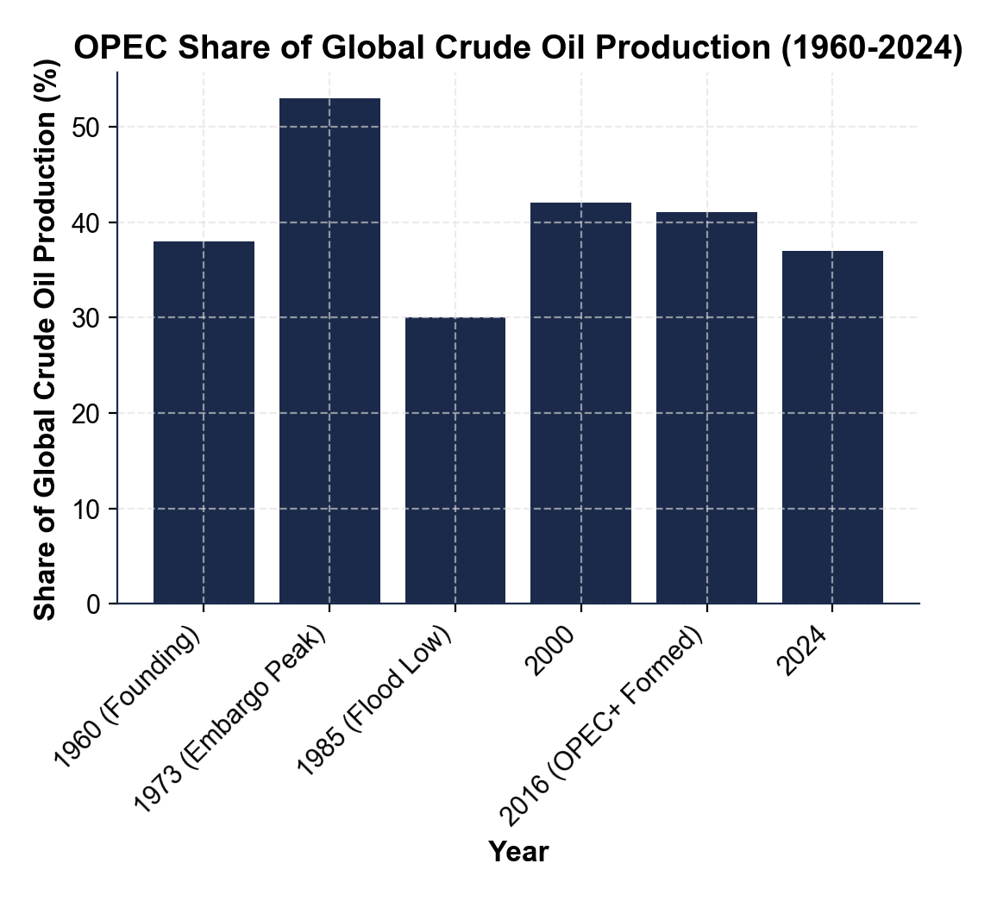

CHART REFERENCE 2: OPEC PRODUCTION QUOTAS VS ACTUAL PRODUCTION (2024)

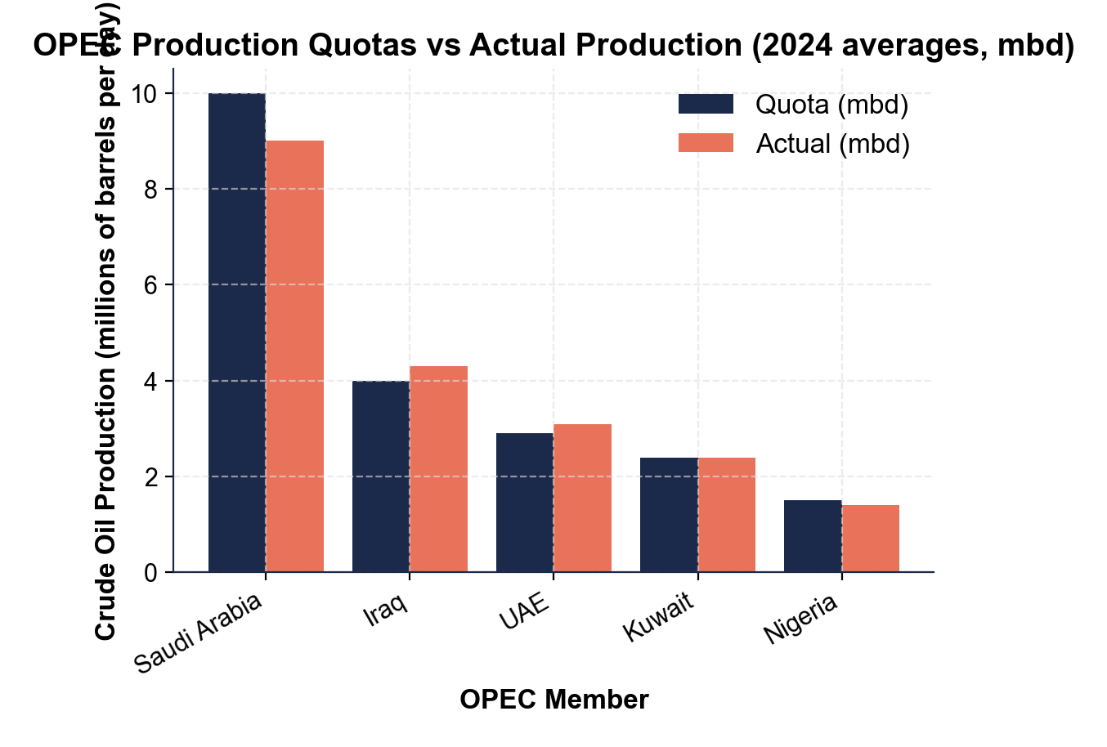

CHART REFERENCE 3: OIL PRICE RESPONSE TO MAJOR OPEC EVENTS (1972-2022)

