ECONOMICS

CARTELS AND COLLUSION - HOW OPEC CONTROLS OIL
ANSWER KEY ACTIVITY

PART 1

OPEC and Cartels Reference Guide - Complete the Missing Terms

Term | Definition
Cartel | A formal agreement among competing producers to limit total output, set production quotas for each member, and raise the market price above the competitive level - OPEC is the most famous example in the world
OPEC | The Organization of the Petroleum Exporting Countries - a cartel founded in Baghdad in 1960 and headquartered in Vienna, Austria; currently 12 member nations producing about 37% of global crude oil
Production quota | Each cartel member's assigned maximum daily output set by the cartel agreement - OPEC quotas are negotiated at twice-yearly ministerial meetings and measured in millions of barrels per day
Cartel cheating | When an individual cartel member produces ABOVE its assigned quota to capture extra revenue at the cartel's expense - the central reason cartels are inherently unstable and tend to collapse
Collusion | Any coordination among competitors to fix prices, divide markets, or restrict output - the broader category that contains cartels; can be EXPLICIT (formal agreement like OPEC) or TACIT (silent price-matching)
Sherman Antitrust Act | The 1890 U.S. federal law that makes most cartels ILLEGAL within the United States; this is why OPEC operates from Vienna and not from U.S. soil, and why no U.S. companies can join
OPEC+ | The expanded coordination group formed in 2016 when Russia and nine other non-OPEC oil producers joined OPEC's production decisions; OPEC+ controls about 48% of global oil supply combined
1973 oil embargo | The first major OPEC action - Arab members halted oil exports to the U.S. over Yom Kippur War support for Israel; oil prices tripled and triggered Western stagflation
Swing producer | The cartel member that adjusts its output UP or DOWN to balance the market when other members cheat - Saudi Arabia plays this role in OPEC because it has the largest reserves and the lowest production costs
Strategic Petroleum Reserve | The U.S. emergency oil stockpile Congress created in 1975 after the 1973 OPEC embargo; the SPR can be released to counter OPEC supply cuts

PART 2

Apply the Terms - OPEC and Cartels Vocabulary in Context
WORD BANK OPEC+ · collusion · cartel · swing producer · production quota
1. Meera asks you to write the opening definition for the memo. A formal agreement among competing producers to limit total output and raise the market price above the competitive level is called a cartel.
cartel. A cartel is a formal agreement among competing producers to limit total output and raise the market price above the competitive level; OPEC is the most famous example in the world.
2. The next term Meera needs is the limit each OPEC member agrees to. Each cartel member is assigned a maximum daily output, negotiated at twice-yearly Vienna meetings and measured in millions of barrels per day - this assigned ceiling is the member's production quota.
production quota
3. Meera explains that a cartel is just one type of a broader behavior. Any coordination among competitors to fix prices, divide markets, or restrict output - the broad category that contains cartels and can be either explicit or tacit - is called collusion.
collusion. Collusion is any coordination among competitors to fix prices, divide markets, or restrict output; it can be explicit like OPEC or tacit like silent price-matching.
4. Meera points to the 2016 expansion. The coordination group formed when Russia and nine other non-OPEC producers joined OPEC production decisions, controlling about 48 percent of global oil supply combined, is called OPEC+.
OPEC+. OPEC+ is the expanded coordination group formed in 2016 when Russia and nine other non-OPEC producers joined OPEC production decisions; together it controls about 48 percent of global oil supply.
5. Finally Meera asks about the member that keeps the cartel alive. The cartel member that adjusts its output up or down to balance the market when others cheat - the role Saudi Arabia plays because it has the largest reserves and lowest production costs - is called the swing producer.
swing producer

PART 3

You Read the Three OPEC Charts with Meera Agarwal at the EIA
1. Use Chart Reference 1 (chart_opec_global_share) - the bar chart showing OPEC's share of global crude oil production in 1960, 1973, 1985, 2000, 2016, and 2024 shown below - to evaluate OPEC's long-run market power.
(a) Read the six percentages off the chart.
PERCENTAGES (from the chart): 1960 = 38%; 1973 = 53%; 1985 = 30%; 2000 = 42%; 2016 = 41%; 2024 = 37%.
(b) Calculate the share drop from the 1973 peak to the 1985 low.
PEAK TO 1985 LOW DROP: 53% - 30% = 23 percentage points lost between the 1973 peak and 1985.
(c) Identify which decade saw the LARGEST decline.
LARGEST DECLINE: The 1973-to-1985 period (the Saudi flood era), driven by Saudi Arabia abandoning cartel discipline and flooding the market to discipline cheating members; the 23-point drop in 12 years is larger than any other decline on the chart.
(d) In 1-2 sentences, explain why OPEC's share has NEVER returned to its 1973 peak even after 50 years.
OPEC's share has NEVER returned to its 1973 peak because (1) U.S. shale production scaled from about 5 million barrels per day in 2008 to over 13 million barrels per day by 2024, adding huge non-OPEC supply that limits OPEC's ability to capture share; AND (2) cartel discipline keeps breaking down - the 1985 Saudi flood, the 2014 shale war, and the 2020 COVID crash all let non-OPEC producers grab market share that OPEC has never fully recovered. The 2024 share of 37% is actually BELOW the 1960 founding level (38%), showing that 65 years of OPEC has not delivered permanent market dominance.
2. Use Chart Reference 2 (chart_opec_quota_vs_actual) - the grouped bar chart showing each major OPEC member's quota and actual daily production (millions of barrels per day) in 2024 shown below - to identify the cartel cheating pattern.
(a) Read each country's quota and actual production.
QUOTA vs ACTUAL (from the chart, all in millions of barrels per day): Saudi Arabia quota 10.0, actual 9.0; Iraq quota 4.0, actual 4.3; UAE quota 2.9, actual 3.1; Kuwait quota 2.4, actual 2.4; Nigeria quota 1.5, actual 1.4.
(b) Identify which members are CHEATING (producing ABOVE quota).
CHEATERS (producing ABOVE quota): IRAQ is producing 0.3 mbd above quota (4.3 vs 4.0); UAE is producing 0.2 mbd above quota (3.1 vs 2.9). Both are cheating to capture extra revenue at the cartel's expense.
(c) Identify which member is the SWING PRODUCER (cutting BELOW quota to absorb the cheating) and calculate how much it is cutting.
SWING PRODUCER = Saudi Arabia. It is producing 1.0 mbd BELOW its quota (9.0 vs 10.0) - voluntarily cutting an extra 1.0 mbd to absorb the cheating by Iraq (+0.3) and UAE (+0.2).
(d) In 1-2 sentences, explain why the cartel only stays together because Saudi Arabia is willing to take the losses.
The cartel only stays together because Saudi Arabia is willing to take the losses. Saudi Arabia is uniquely positioned to absorb the cuts because it has the largest reserves (~267 billion barrels) and the lowest per-barrel production costs (~$3/barrel).

3. Use Chart Reference 3 (chart_oil_price_opec_events) - the bar chart showing the average Brent crude oil price (USD per barrel) in the year of seven major OPEC events shown below - to evaluate OPEC's historical pricing power.
(a) Read all seven price points.
PRICE POINTS (from the chart, USD per barrel): 1972 = $3 (pre-embargo); 1974 = $11 (post-embargo); 1986 = $14 (Saudi flood); 2008 = $97 (peak); 2015 = $52 (shale war); 2020 = $42 (COVID); 2022 = $99 (Ukraine).
(b) Identify the multiplier on the 1972-to-1974 embargo jump (price ratio).
EMBARGO MULTIPLIER: $11 / $3 = 3.67x in two years - more than tripling. This was the most rapid major price increase in oil history and triggered U.S. stagflation.
(c) Identify what happened in 1986 (the Saudi flood collapse) and what the 1986 price level shows about cartel discipline.
THE 1986 SAUDI FLOOD: Prices crashed from about $30 per barrel in 1985 to $14 by 1986 (down to under $10 briefly) as Saudi Arabia abandoned the swing producer role and ramped production to maximum.
(d) In 1-2 sentences, predict whether OPEC can sustain $90+ prices long term given that U.S. shale survived two Saudi price wars (1985 and 2014).
PROJECTION FOR $90+ PRICES: OPEC will struggle to sustain $90+ prices long-term because (1) U.S. shale production has TWICE survived Saudi price wars (1985 vs Soviet/non-OPEC oil; 2014 vs U.S. shale) by cutting costs aggressively; (2) shale wells can be shut in and restarted in months, giving non-OPEC supply elasticity OPEC does not have. The 2022 spike to $99 came from the Russia-Ukraine war (a geopolitical shock), not OPEC pricing power. Without another geopolitical shock, the long-run equilibrium oil price is likely to settle in the $60-80 range driven by shale break-even costs - meaningfully below the $90+ levels OPEC would prefer.

PART 4

Four Real Scenarios with Meera Agarwal - Apply the Model
1. THE CHEATING INCENTIVE QUESTION. Meera hands you a 2024 OPEC compliance memo: 8 of the 12 members produced above their assigned quotas at some point during the year. Meera asks: why does this keep happening?
(a) Walk through the basic economic logic of the cheating incentive (use the $40-to-$80 example from Part 1).
THE CHEATING INCENTIVE: When OPEC succeeds at raising prices from say $40 to $80 per barrel, each individual member faces this math: 'if I quietly produce 200,000 extra barrels per day at $80, I capture an extra $16 million per day in revenue.
(b) Identify ONE specific OPEC member that chronically cheats and explain its motivation (Iraq is the clearest case - explain why).
IRAQ IS THE CLEAREST CHRONIC CHEATER. Iraq has been chronically over quota for the past decade. Iraq's motivation is fiscal: oil revenue is about 90% of Iraqi government revenue, the country is rebuilding from the 2003-2017 wars and ISIS occupation, and the central government desperately needs cash.
(c) Argue whether OPEC can ever SOLVE the cheating problem internally.
CAN OPEC SOLVE CHEATING INTERNALLY? NO, NOT PERMANENTLY. OPEC has no formal enforcement mechanism - there is no fine, no expulsion process actually used, no monitoring with teeth. Saudi Arabia's swing producer role is the only enforcement tool, but it shifts the cost ONTO Saudi Arabia and creates resentment over time. The 1985 Saudi flood and 2014 shale war were Saudi Arabia's attempts to PUNISH cheaters - and both events nearly destroyed OPEC. Internal enforcement is fundamentally impossible because no member has the legal authority to enforce against another sovereign state.
(d) Identify ONE specific structural reform OPEC could adopt that would reduce cheating - and explain why members would resist it.
ONE REFORM: Independent third-party production monitoring (currently done by S&P Global Platts) could be CONTRACTUALIZED with financial penalties tied to a Vienna-based escrow account. Members who exceed quota would pay into the escrow; members who undercut quota (the swing producer absorption) would receive payments from it. WHY MEMBERS WOULD RESIST: This would formalize cheating measurement and force members to acknowledge violations publicly - politically embarrassing. It would also require members to put cash into an escrow ahead of compliance, which cash-starved members like Venezuela, Nigeria, and Iraq cannot afford. Members LIKE the current ambiguous system because cheating is plausibly deniable.
2. THE SAUDI SWING PRODUCER DILEMMA. The Saudi swing producer role keeps OPEC alive but costs Saudi Arabia roughly $30 billion per year in foregone revenue (cutting 1 mbd at $80/barrel for 365 days = $29.2 billion). Meera asks: why does Saudi Arabia keep doing this?
(a) Identify TWO specific economic reasons Saudi Arabia accepts the swing producer cost.
TWO ECONOMIC REASONS: (i) PRICE STABILITY OUTWEIGHS VOLUME LOSS. At $80/barrel and 9 mbd, Saudi Arabia earns about $263 billion per year from oil. If Saudi Arabia stopped swinging and prices crashed to $30 (as in 1986 and 2014), even at 11 mbd Saudi would earn only $120 billion - a $143 billion LOSS. The $30B/year swing producer cost is cheap insurance against a $143B/year price crash. (ii) LOW PRODUCTION COSTS. Saudi Arabia produces oil at about $3/barrel cost (the cheapest in the world); even cutting 1 mbd from production costs Saudi Arabia very little in actual production expenses - the loss is only in revenue. Saudi Aramco's economics are uniquely positioned to absorb cuts because of these structural cost advantages.
(b) Identify ONE specific political reason Saudi Arabia accepts the cost.
ONE POLITICAL REASON: OPEC LEADERSHIP. Being the swing producer makes Saudi Arabia the indispensable OPEC member - all other members defer to Saudi production decisions, Saudi ministers chair OPEC meetings, and Saudi Arabia gets first-call influence on global oil pricing. Without the swing producer role, Saudi Arabia would just be the largest of 12 cheating members with no special status.
(c) Argue under what conditions Saudi Arabia might ABANDON the swing producer role again (like 1985 and 2014).
WHEN SAUDI ARABIA MIGHT ABANDON SWING PRODUCER ROLE AGAIN: (i) When other members' cheating becomes egregiously large (Saudi cuts 2+ mbd while Iraq and UAE add 1+ mbd each - the math stops working); (ii) When non-OPEC competition (U.S. shale, Brazilian pre-salt) is growing rapidly and Saudi cuts just hand market share to non-OPEC; (iii) When Saudi Arabia needs short-term revenue for a specific project (the 2017-2019 swing producer cuts were partially offset by the Saudi Aramco IPO needs); (iv) When a new technology threatens long-run oil demand (electric vehicles in the 2030s) - Saudi Arabia may pump everything to monetize reserves before they become stranded assets.
(d) Predict what would happen to OPEC if Saudi Arabia permanently quit the swing producer role.
IF SAUDI ARABIA PERMANENTLY QUIT THE SWING PRODUCER ROLE: OPEC would functionally cease as a price-management cartel within 12-24 months. The cartel could continue to EXIST formally but without enforcement it could not move prices.
3. THE OPEC+ RUSSIA QUESTION. OPEC+ was formed in December 2016 by adding Russia and 9 other non-OPEC producers to OPEC's production decisions. Meera asks: was this a smart move?
(a) Identify ONE specific reason OPEC needed Russia after the 2014-2016 shale war.
ONE REASON OPEC NEEDED RUSSIA: After the 2014-2016 shale price war, OPEC realized it could not manage prices alone. Russia produces about 11 mbd - meaningfully more than any individual OPEC member except Saudi Arabia.
(b) Identify ONE specific risk OPEC took by adding Russia.
ONE RISK FROM ADDING RUSSIA: Russia is a sovereign state with its own geopolitical agenda that frequently conflicts with OPEC members. The 2022 Ukraine invasion triggered Western sanctions that fundamentally changed Russian oil flows (now mostly to China and India).
(c) Argue whether OPEC+ has been more or less stable than the old OPEC-only structure.
HAS OPEC+ BEEN MORE OR LESS STABLE? MORE STABLE in pricing power, LESS STABLE politically. OPEC+ has maintained prices in the $70-100 range since 2016 (with the 2020 COVID exception) - meaningfully higher than OPEC could have managed alone given shale competition. However, the political coordination is fragile: the April 2020 collapse came when Saudi Arabia and Russia briefly broke off cooperation, triggering the negative-price episode. OPEC+ delivers MORE pricing power but THE COORDINATION CAN COLLAPSE FASTER because more parties means more failure points.
(d) Argue whether Russia's 2022 invasion of Ukraine STRENGTHENED or WEAKENED OPEC+ - and explain your reasoning.
DID THE 2022 UKRAINE INVASION STRENGTHEN OR WEAKEN OPEC+? STRENGTHENED IN THE SHORT RUN, WEAKENED LONG RUN. SHORT RUN STRENGTH: The invasion plus OPEC+ cuts pushed prices to $99 in 2022 (Chart 3), the second-highest level in history. Russia needed OPEC+ cooperation more than ever to keep prices elevated against Western sanctions. LONG RUN WEAKNESS: Russia became politically toxic to many Western governments; the U.S. and EU put political pressure on Saudi Arabia to DISTANCE itself from Russia in OPEC+. Saudi Arabia's 2025 visit to Washington signaled a partial pivot. The Russia-Ukraine war highlighted that OPEC+ now contains a fundamentally rogue actor (Russia) whose political risks may exceed the production-coordination benefits.
4. THE U.S. POLICY CHOICE. Meera asks: what should the U.S. do about OPEC's market power? She gives you four options to evaluate.
(a) Make the case for OPTION 1 - INCREASE DOMESTIC SHALE PRODUCTION (lease more federal land, accelerate permitting, push U.S. production from 13 to 16 mbd).
OPTION 1 - INCREASE DOMESTIC SHALE: ARGUMENT FOR: U.S. shale has TWICE defeated Saudi price wars (1985 indirect, 2014 direct) by being cost-competitive at $50-60 levels. Increasing U.S. shale to 16 mbd would push OPEC's effective market share from 37% toward 30% and remove the price floor OPEC needs. CONS: U.S. environmental opposition, water resource constraints in shale basins, and the political fight over federal land leasing.
(b) Make the case for OPTION 2 - RELEASE THE STRATEGIC PETROLEUM RESERVE more aggressively to counter OPEC supply cuts.
OPTION 2 - SPR RELEASES: ARGUMENT FOR: The Strategic Petroleum Reserve currently holds ~360 million barrels (down from 714M capacity after Biden's 2022 releases). Aggressive releases (1+ mbd) can offset OPEC supply cuts for 6-12 months. The 2022 Biden releases (~180 million barrels) demonstrably moved global prices by $10-15/barrel. CONS: SPR has been depleted; refilling is slow and expensive; one-time releases cannot defeat a structural OPEC cut.
(c) Make the case for OPTION 3 - ACCELERATE THE ELECTRIC VEHICLE TRANSITION to reduce oil demand.
OPTION 3 - ELECTRIC VEHICLES: ARGUMENT FOR: Long-run oil demand reduction is the ONLY policy that permanently neutralizes OPEC. Every EV on the road reduces gasoline demand by about 500 gallons/year. If U.S. EVs reach 50% of new car sales (Biden EPA goal), U.S. oil demand could fall 3-4 mbd by 2035 - structural demand destruction OPEC cannot counter. CONS: 10-15 year payoff timeline; depends on Chinese battery supply chain; charging infrastructure cost.
(d) Make the case for OPTION 4 - COORDINATE WITH OTHER CONSUMER NATIONS (EU, Japan, India, China) to push back against OPEC pricing. Pick one and explain.
OPTION 4 - CONSUMER NATION COORDINATION: ARGUMENT FOR: The International Energy Agency (IEA) was originally set up in 1974 specifically to coordinate consumer nation oil reserves against OPEC. If the U.S., EU, Japan, and India coordinate SPR releases simultaneously, OPEC's pricing power weakens significantly. China is not in IEA but could be invited. CONS: Geopolitical conflicts (China, EU) make coordination hard; each country has different SPR sizes and refining needs. PICK ONE: OPTION 3 (ELECTRIC VEHICLE TRANSITION) is the most powerful long-run option because it permanently SHRINKS the oil demand pool OPEC competes for. The 2014 and 2020 episodes prove that OPEC pricing power evaporates when demand drops - permanently shrinking demand is the structural solution. OPTION 1 (shale) is a useful complement in the medium term (5-10 years). Combining OPTIONS 1 + 3 - aggressive shale plus aggressive EV transition - delivers both short-run and long-run OPEC neutralization. COUNTERARGUMENT: SPR releases (Option 2) are the only emergency tool when OPEC cuts in an active crisis - they cannot be the long-run strategy but should be kept fully stocked for the next OPEC supply shock.

PART 5

Your Final Briefing Memo to Meera Agarwal
EIA OPEC POLICY RECOMMENDATION MEMO
1. Meera closes the assignment.
A state senator wants the EIA to recommend what the United States should do about OPEC market power over the next 5 to 10 years, and Meera is handing the draft to you. Using your work from Parts 1 through 4, and using all four required terms (cartel, production quota, cartel cheating, swing producer) at least once each, what is your final 6 to 8 sentence briefing memo recommending what U.S. policy should do about OPEC market power?
YOUR RESPONSE MUST:
☐ Names a SPECIFIC U.S. POLICY OPTION (increase shale production, release SPR, accelerate EV transition, or coordinate consumer nations) AND ties the choice to the nature of OPEC market power.
☐ Uses the term CARTEL correctly - identifies OPEC as a formal agreement among competing producers to limit output and raise prices.
☐ Uses the term PRODUCTION QUOTA correctly - identifies it as each OPEC member's assigned maximum daily output.
☐ Uses the term CARTEL CHEATING correctly - identifies it as the structural reason OPEC is inherently unstable.
☐ Uses the term SWING PRODUCER correctly - identifies Saudi Arabia's role absorbing cheating to hold the cartel together.
☐ Quotes at least ONE specific value from the chart appendix (the 53% OPEC 1973 peak, the 37% 2024 share, the $99 2022 price, the 9.7 mbd 2020 COVID cut, the Iraq +0.3 mbd cheating, or another) to ground the recommendation in real data.
☐ Closes with a SPECIFIC PROCEDURAL NEXT STEP the U.S. should take (e.g., increase federal land leasing for shale by X%, refill SPR to 500 million barrels by 2027, accelerate EV tax credits, convene IEA coordination meeting).
MEMO
To: Meera Agarwal, Senior Energy Analyst
From: [student completes]
Date: [student completes]
Re: U.S. Policy Recommendation on OPEC Market Power
GRADING RUBRIC
Grade the evidence and reasoning, not the conclusion — any defensible position is valid. Score against the 7 requirements above.
FULL CREDIT — clear position; meets all 7 requirements with accurate, specific numbers and evidence from the lesson.
PARTIAL — position stated, but misses 1-2 requirements or uses vague / incorrect numbers.
MINIMAL — no clear position, or missing most requirements and numbers.
WHAT TO LOOK FOR IN THIS LESSON
Graded by the rubric below. A full-credit memo: (Policy) names a specific U.S. option (accelerate EV transition, increase shale, release SPR, or coordinate consumer nations) and ties it to OPEC market power. (Cartel) identifies OPEC as a formal agreement among competing producers to limit output and raise prices. (Production quota) identifies each member assigned maximum daily output set in Vienna. (Cartel cheating) identifies the structural reason OPEC is unstable. (Swing producer) identifies Saudi Arabia absorbing the cheating to hold the cartel together. (Data) quotes one chart number (the 53% 1973 peak, the 37% 2024 share, the $99 2022 price, the 9.7 mbd 2020 cut, or the Iraq +0.3 mbd cheating). (Next step) closes with one concrete U.S. action. About 6 to 8 sentences. The lever choice can vary - the grade is for reasoning, not for picking one right answer.

CHART REFERENCE 1: OPEC SHARE OF GLOBAL CRUDE OIL PRODUCTION (1960-2024)

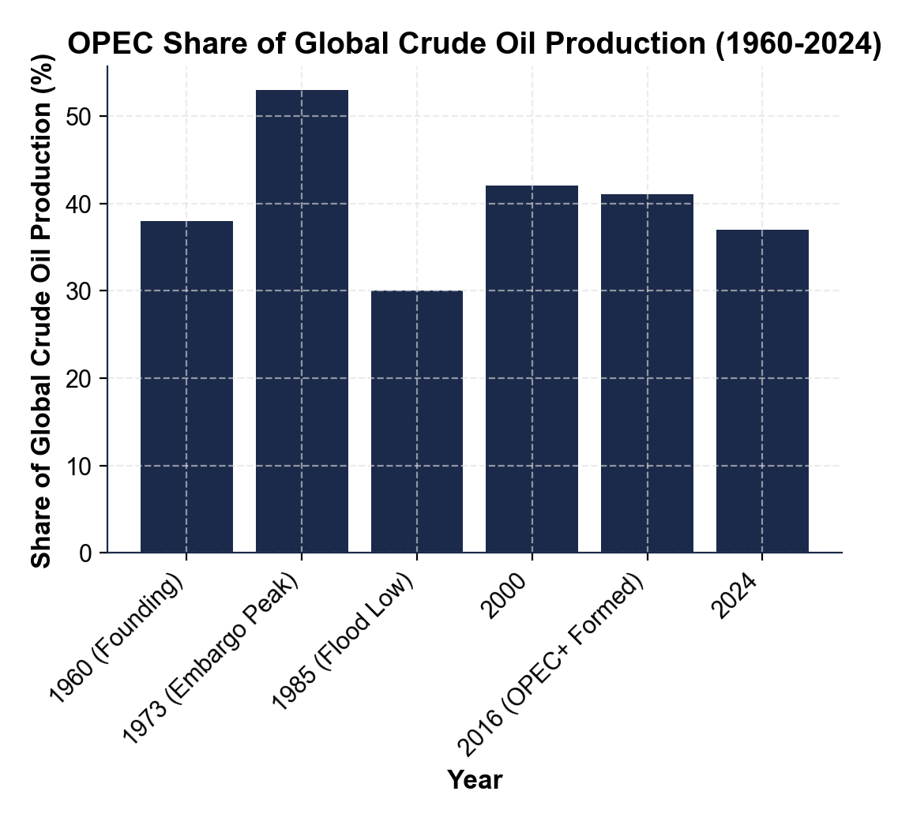

CHART REFERENCE 2: OPEC PRODUCTION QUOTAS VS ACTUAL PRODUCTION (2024)

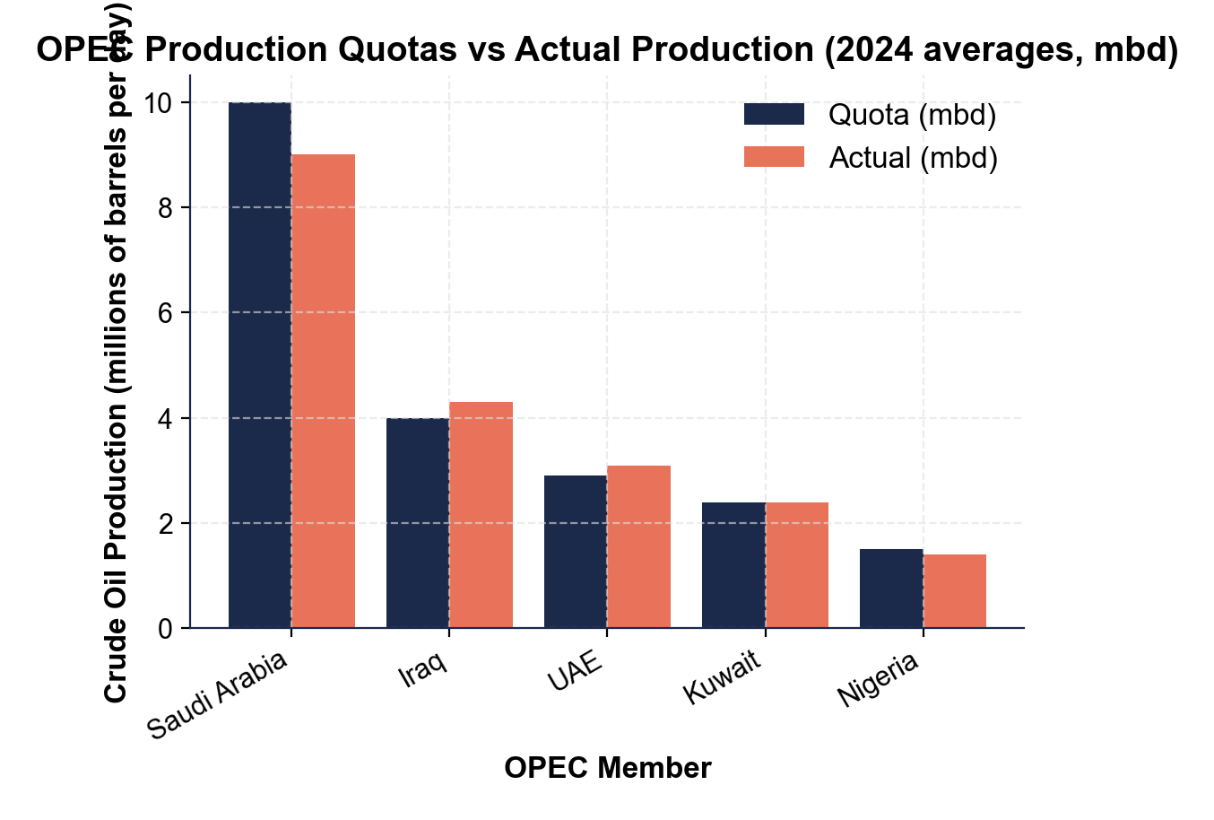

CHART REFERENCE 3: OIL PRICE RESPONSE TO MAJOR OPEC EVENTS (1972-2022)

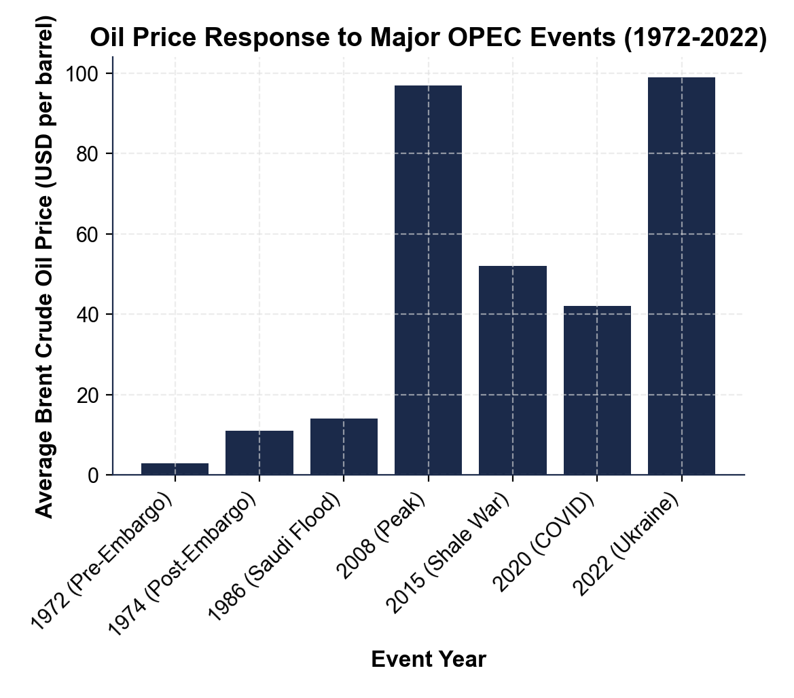
MORE LESSONS LESS PLANNING
Thank You!
If you enjoyed this product, please do not forget to rate and review to assist other teachers.

Looking for future discounts? Earn TPT credits by reviewing purchased products.

Please contact me if you have any issues with this product. Just like our students, I am always looking for opportunities to grow.

