Bonds: Lending to Governments & Companies
STUDENT ACTIVITY
Name: | Date: | Period:
ESSENTIAL QUESTION
What does it mean to buy a bond and become a LENDER to a government or company, what are the parts of a bond - the face value, the coupon (interest) payment found with COUPON PAYMENT = FACE VALUE x COUPON RATE, and the maturity - and how does a bond compare to a stock in risk and return?
THE SCENARIO
You are helping MARIA DELGADO, a first-time bond investor who just bought one bond from GreenLeaf Foods with a FACE VALUE of $1,000.00 - which means she LENT the company $1,000. A BOND is a loan you make to a government or company, so buying this bond makes Maria a LENDER, not an owner.
BY THE END, YOU CAN:
✓ Explain what a bond is and how lending to an issuer differs from owning a stock
✓ Identify the parts of a bond: the face value, the coupon (interest) payment, and the maturity date
✓ Calculate a bond's yearly interest using COUPON PAYMENT = FACE VALUE x COUPON RATE
✓ Compare bonds and stocks in risk and return, and explain when a bond makes sense
HOW IT WORKS (do Parts 1–5 in order)
Part 1 — Bonds Reference Guide - Complete the Missing Terms
Part 2 — Apply the Terms - Bond Vocabulary in Context
Part 3 — Read the Chart - Risk vs Return: Bonds vs Stocks
Part 4 — Do the Bond Math - The Coupon, the Interest, and the Maturity Payback
Part 5 — Lending vs Owning - Make Your Recommendation
TIME about 45 minutes YOU’LL NEED the lesson slides and your Guided Notes.

PART 1

Bonds Reference Guide - Complete the Missing Terms
Fill in the missing term for each blank row — the definition is your clue. Your Guided Notes and the lesson slides have every term.

Term | Definition
___________ | A loan you make to a government or company; in return they pay you fixed interest and return your money on a set date
Issuer | The government or company that borrows the money by selling the bond; the issuer owes the bondholder interest and the face value
___________ | The amount printed on the bond - what you lend the issuer and what they return to you at maturity (also called par)
Coupon rate | The fixed yearly interest rate a bond pays, set as a percent of the face value
___________ | The fixed interest a bond pays each year: face value times the coupon rate
Fixed income | An investment that pays a set, predictable amount on a schedule; bonds are the main example
___________ | The set date when the bond ends and the issuer returns the face value to the bondholder
Bondholder | The person who owns the bond and lends the money; the lender the issuer must pay back
___________ | When an issuer fails to make its interest payments or return the face value; the main risk of owning a bond
Government bond | A bond issued by a government (such as a U.S. Treasury bond), usually the lowest-risk kind of bond

PART 2

Apply the Terms - Bond Vocabulary in Context
WORD BANK bond · coupon payment · maturity · face value · default
1. Q1. A loan you make to a government or company that pays you fixed interest and returns your money on a set date - the thing Maria bought from GreenLeaf - is called a .

2. Q2. The amount printed on the bond - what Maria lends the issuer and what GreenLeaf returns to her at maturity, which is $1,000 - is the .

3. Q3. The fixed interest a bond pays each year, found with FACE VALUE x COUPON RATE - Maria's $50 a year - is the (interest) .

4. Q4. The set date when the bond ends and GreenLeaf returns Maria's $1,000 face value - 4 years away - is the date.

5. Q5. When an issuer fails to make its interest payments or return the face value - the main risk of owning a bond - is called .

PART 3

Read the Chart - Risk vs Return: Bonds vs Stocks
1. As you help Maria Delgado, study the grouped bar chart on this page titled "Risk vs Return: Bonds vs Stocks (a 1-10 comparison)." It shows the typical risk and typical return of bonds and of stocks on a 1-to-10 scale (1 = low, 10 = high). Read the chart and write:
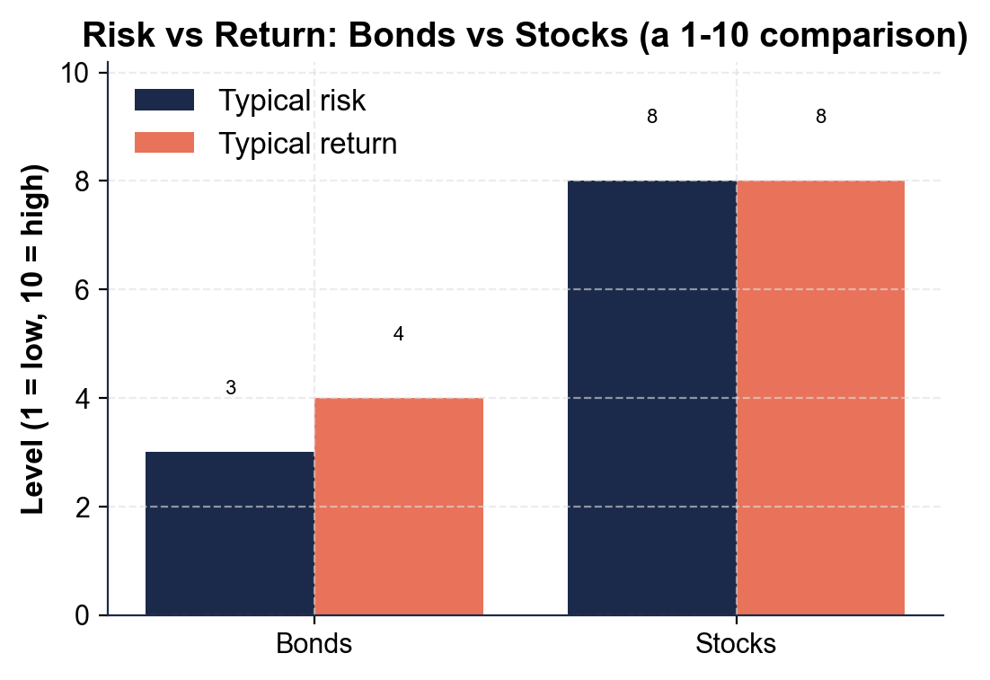
(a) the typical RISK level

(b) the typical RETURN level for BONDS.

2. As you help Maria Delgado, use the same chart to read the STOCK bars.
(a) What is the typical RISK level and the typical RETURN level for STOCKS?

(b) Compared with bonds, are stocks HIGHER or LOWER on both risk and return?

3. As you help Maria Delgado, look at what the chart shows about the trade-off between bonds and stocks. In one or two sentences, explain what the bars tell you about how risk and return move together. Start your answer with: "The chart shows that..."

PART 4

Do the Bond Math - The Coupon, the Interest, and the Maturity Payback
1. As you help Maria Delgado, start with the COUPON PAYMENT - the fixed interest the bond pays each year.
Maria's bond has a $1,000.00 face value and a 5% coupon rate. Use COUPON PAYMENT = FACE VALUE x COUPON RATE. (a) What is the yearly coupon payment? Show your math.

2. As you help Maria Delgado, find the TOTAL INTEREST over the life of the bond.
The coupon payment is $50.00 a year, and the bond's MATURITY is 4 years away. (a) How much interest does Maria collect over all 4 years (coupon payment x years)? Show your math.

3. As you help Maria Delgado, figure out what happens AT MATURITY and what Maria earned in total. Maria paid the $1,000.00 face value for the bond (bought at par).
(a) How much does GreenLeaf return to Maria at maturity?

(b) What are Maria's total EARNINGS from the bond - count only the interest she collected, not the $1,000 face value returned at maturity? Show your math.

4. As you help Maria Delgado, find the TOTAL RETURN as a percent. Maria earned $200.00 in interest on the $1,000.00 she lent.
(a) What percent of the $1,000 is her total return over the 4 years (total interest / face value)?

(b) About what percent a year is that? Show your math.

5. As you help Maria Delgado, use the same model on a GOVERNMENT bond. Maria's friend buys a $2,000.00 face-value U.S. Treasury bond (the government is the issuer) with a 4% coupon rate and a 3-year maturity.
(a) What is the yearly coupon payment (face value x coupon rate)?

(b) How much interest over the 3 years, and how much does the government return at maturity? Show your math.

PART 5

Lending vs Owning - Make Your Recommendation
1. As you help Maria Delgado, explain the core idea of lending.
(a) What does it mean that Maria bought a BOND from GreenLeaf Foods - is she an owner or a lender, and what is GreenLeaf called?

(b) How is buying a bond different from buying a stock?

(c) Name one thing the issuer promises the bondholder.

2. As you help Maria Delgado, explain the parts of the bond and how it pays.
(a) What is the COUPON (interest) PAYMENT, and how much is Maria's each year?

(b) What happens at the MATURITY date?

(c) Why are bonds called FIXED INCOME?

3. As you help Maria Delgado, compare the bond to a stock and think about risk.
(a) How does a bond compare to a stock in RISK and RETURN?

(b) What is the main risk of a bond called, and what does it mean?

(c) Name one situation when a bond makes more sense than a stock.

FINAL RECOMMENDATION
4. FINAL RECOMMENDATION. Maria asks you to put it in writing. Write a 5-7 sentence note (120-180 words) telling Maria what buying this bond means, how it pays her, and how a bond compares to a stock in risk and return. Check off each required element as you include it.
YOUR RESPONSE MUST:
☐ EXPLAIN LENDING - state in your own words that a bond is a loan to a government or company, so buying it made Maria a lender (a bondholder), and GreenLeaf the issuer who owes her.
☐ NAME THE PARTS - name the key parts of the bond: the face value ($1,000 lent and returned), the coupon (interest) payment (the fixed yearly interest), and the maturity (the payback date).
☐ USE A CALCULATED RESULT - state a figure you calculated yourself in Part 4 (for example, the $50 yearly coupon using COUPON PAYMENT = FACE VALUE x COUPON RATE, the $200 total interest, or the 20% total return).
☐ COMPARE TO A STOCK - explain that a bond is usually lower risk and lower return than a stock, because you lend (fixed, promised payments) instead of own (uncertain profits).
☐ GIVE CLEAR ADVICE - give Maria one specific situation when a bond makes sense (for example, for steady income, money she cannot lose, or to balance out riskier stocks), and remind her to check the issuer.

