PERSONAL FINANCE

BONDS: LENDING TO GOVERNMENTS & COMPANIES
ANSWER KEY ACTIVITY - ANSWER KEY

PART 1

Bonds Reference Guide - Complete the Missing Terms

Term | Definition
Bond | A loan you make to a government or company; in return they pay you fixed interest and return your money on a set date
Issuer | The government or company that borrows the money by selling the bond; the issuer owes the bondholder interest and the face value
Face value | The amount printed on the bond - what you lend the issuer and what they return to you at maturity (also called par)
Coupon rate | The fixed yearly interest rate a bond pays, set as a percent of the face value
Coupon (interest) payment | The fixed interest a bond pays each year: face value times the coupon rate
Fixed income | An investment that pays a set, predictable amount on a schedule; bonds are the main example
Maturity | The set date when the bond ends and the issuer returns the face value to the bondholder
Bondholder | The person who owns the bond and lends the money; the lender the issuer must pay back
Default | When an issuer fails to make its interest payments or return the face value; the main risk of owning a bond
Government bond | A bond issued by a government (such as a U.S. Treasury bond), usually the lowest-risk kind of bond

PART 2

Apply the Terms - Bond Vocabulary in Context
WORD BANK bond · coupon payment · maturity · face value · default
1. Q1. A loan you make to a government or company that pays you fixed interest and returns your money on a set date - the thing Maria bought from GreenLeaf - is called a Bond.
Bond
2. Q2. The amount printed on the bond - what Maria lends the issuer and what GreenLeaf returns to her at maturity, which is $1,000 - is the Face value.
Face value
3. Q3. The fixed interest a bond pays each year, found with FACE VALUE x COUPON RATE - Maria's $50 a year - is the Coupon (interest) payment.
Coupon payment
4. Q4. The set date when the bond ends and GreenLeaf returns Maria's $1,000 face value - 4 years away - is the Maturity date.
Maturity
5. Q5. When an issuer fails to make its interest payments or return the face value - the main risk of owning a bond - is called Default.
Default

PART 3

Read the Chart - Risk vs Return: Bonds vs Stocks
1. As you help Maria Delgado, study the grouped bar chart on this page titled "Risk vs Return: Bonds vs Stocks (a 1-10 comparison)." It shows the typical risk and typical return of bonds and of stocks on a 1-to-10 scale (1 = low, 10 = high). Read the chart and write:
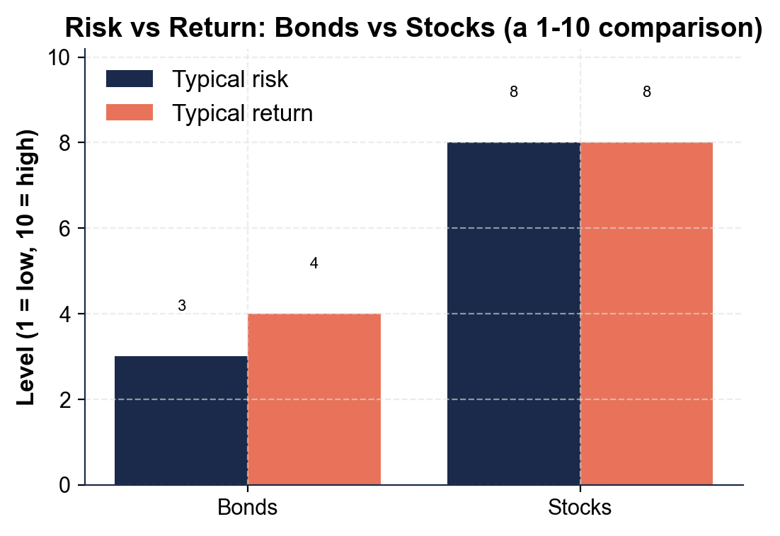
(a) the typical RISK level
(b) the typical RETURN level for BONDS.
(1) For BONDS, the typical RISK level is 3 (a low bar). (2) For BONDS, the typical RETURN level is 4 (a low bar). Accept a bond risk of 3 and a bond return of 4 read off the two bond bars.
2. As you help Maria Delgado, use the same chart to read the STOCK bars.
(a) What is the typical RISK level and the typical RETURN level for STOCKS?
(b) Compared with bonds, are stocks HIGHER or LOWER on both risk and return?
(1) For STOCKS, the typical RISK level is 8 and the typical RETURN level is 8 (both high bars). (2) Compared with bonds, stocks are HIGHER on BOTH risk and return - a bond's 3 and 4 are lower than a stock's 8 and 8. Accept stock risk 8, stock return 8, and 'higher on both.'
3. As you help Maria Delgado, look at what the chart shows about the trade-off between bonds and stocks. In one or two sentences, explain what the bars tell you about how risk and return move together. Start your answer with: "The chart shows that..."
The chart shows that risk and return rise together: bonds sit low on BOTH risk (3) and return (4), while stocks sit high on BOTH risk (8) and return (8). You cannot get the higher return of stocks without accepting more risk, and a bond's lower risk comes with a lower return - that is the risk/return trade-off. Accept any answer that says bonds are lower on both while stocks are higher on both, and that more return comes with more risk (the trade-off).

PART 4

Do the Bond Math - The Coupon, the Interest, and the Maturity Payback
1. As you help Maria Delgado, start with the COUPON PAYMENT - the fixed interest the bond pays each year.
Maria's bond has a $1,000.00 face value and a 5% coupon rate. Use COUPON PAYMENT = FACE VALUE x COUPON RATE. (a) What is the yearly coupon payment? Show your math.
(1) COUPON PAYMENT = $1,000.00 x 5% = $1,000.00 x 0.05 = $50.00 a year. Accept $50.00 (the fixed interest GreenLeaf pays Maria each year for lending the money).
2. As you help Maria Delgado, find the TOTAL INTEREST over the life of the bond.
The coupon payment is $50.00 a year, and the bond's MATURITY is 4 years away. (a) How much interest does Maria collect over all 4 years (coupon payment x years)? Show your math.
(1) TOTAL INTEREST = $50.00 x 4 years = $200.00. Accept $200.00 (the $50 fixed coupon collected each year for the 4 years to maturity).
3. As you help Maria Delgado, figure out what happens AT MATURITY and what Maria earned in total. Maria paid the $1,000.00 face value for the bond (bought at par).
(a) How much does GreenLeaf return to Maria at maturity?
(b) What are Maria's total EARNINGS from the bond - count only the interest she collected, not the $1,000 face value returned at maturity? Show your math.
(1) AT MATURITY GreenLeaf returns the $1,000.00 face value - Maria's original money back. (2) TOTAL EARNINGS = $200.00 in interest only; the $1,000 face value returned is her own money back, not profit. Accept a $1,000 face value returned and $200 total earned.
4. As you help Maria Delgado, find the TOTAL RETURN as a percent. Maria earned $200.00 in interest on the $1,000.00 she lent.
(a) What percent of the $1,000 is her total return over the 4 years (total interest / face value)?
(b) About what percent a year is that? Show your math.
(1) TOTAL RETURN = $200.00 / $1,000.00 = 0.20 = 20% over the 4 years. (2) PER YEAR = 20% / 4 years = 5% a year (the same as the coupon rate). Accept a 20% total return over 4 years and about 5% a year.
5. As you help Maria Delgado, use the same model on a GOVERNMENT bond. Maria's friend buys a $2,000.00 face-value U.S. Treasury bond (the government is the issuer) with a 4% coupon rate and a 3-year maturity.
(a) What is the yearly coupon payment (face value x coupon rate)?
(b) How much interest over the 3 years, and how much does the government return at maturity? Show your math.
(1) COUPON PAYMENT = $2,000.00 x 4% = $80.00 a year. (2) TOTAL INTEREST = $80.00 x 3 years = $240.00, and at maturity the government returns the $2,000.00 face value. Accept an $80 yearly coupon, $240 total interest, and $2,000 returned - the same coupon model on a different issuer.

PART 5

Lending vs Owning - Make Your Recommendation
1. As you help Maria Delgado, explain the core idea of lending.
(a) What does it mean that Maria bought a BOND from GreenLeaf Foods - is she an owner or a lender, and what is GreenLeaf called?
Buying a bond means Maria LENT GreenLeaf money, so she is a LENDER (a bondholder), not an owner; GreenLeaf is the ISSUER - the borrower who owes her the money back.
(b) How is buying a bond different from buying a stock?
A bond makes you a LENDER who is owed a fixed, promised payment and your face value back, while a stock makes you an OWNER who shares in the company's uncertain profits and growth (and losses).
(c) Name one thing the issuer promises the bondholder.
Accept any one of: the issuer promises to pay the fixed coupon (interest) each year, and to return the face value at maturity; lenders are also paid before owners if the company struggles.
2. As you help Maria Delgado, explain the parts of the bond and how it pays.
(a) What is the COUPON (interest) PAYMENT, and how much is Maria's each year?
The COUPON (interest) PAYMENT is the fixed interest the bond pays each year, found with FACE VALUE x COUPON RATE; Maria's is $1,000 x 5% = $50 a year.
(b) What happens at the MATURITY date?
At MATURITY the bond ends and GreenLeaf returns Maria's $1,000 face value - her original money back - after she has collected all four $50 coupons ($200 total).
(c) Why are bonds called FIXED INCOME?
Bonds are FIXED INCOME because they pay a set, predictable amount on a schedule - Maria's $50 comes every year no matter what the stock market does. Award credit for defining the coupon ($50 a year), explaining maturity ($1,000 returned), and defining fixed income (a set, predictable payment).
3. As you help Maria Delgado, compare the bond to a stock and think about risk.
(a) How does a bond compare to a stock in RISK and RETURN?
A bond is usually LOWER RISK and LOWER RETURN than a stock: you lend for a fixed, promised coupon (steady but modest), while a stock is higher risk and higher average return because you own uncertain profits.
(b) What is the main risk of a bond called, and what does it mean?
The main risk of a bond is DEFAULT - the issuer failing to make its interest payments or return the face value; it is rare for strong issuers, which is why bonds are lower risk.
(c) Name one situation when a bond makes more sense than a stock.
Accept any sound situation: when you want steady, predictable income; when you cannot afford to lose the money or will need it soon-ish; to balance out riskier stocks; or for a goal with a deadline (using the maturity date).
FINAL RECOMMENDATION
4. FINAL RECOMMENDATION. Maria asks you to put it in writing. Write a 5-7 sentence note (120-180 words) telling Maria what buying this bond means, how it pays her, and how a bond compares to a stock in risk and return. Check off each required element as you include it.
YOUR RESPONSE MUST:
☐ EXPLAIN LENDING - state in your own words that a bond is a loan to a government or company, so buying it made Maria a lender (a bondholder), and GreenLeaf the issuer who owes her.
☐ NAME THE PARTS - name the key parts of the bond: the face value ($1,000 lent and returned), the coupon (interest) payment (the fixed yearly interest), and the maturity (the payback date).
☐ USE A CALCULATED RESULT - state a figure you calculated yourself in Part 4 (for example, the $50 yearly coupon using COUPON PAYMENT = FACE VALUE x COUPON RATE, the $200 total interest, or the 20% total return).
☐ COMPARE TO A STOCK - explain that a bond is usually lower risk and lower return than a stock, because you lend (fixed, promised payments) instead of own (uncertain profits).
☐ GIVE CLEAR ADVICE - give Maria one specific situation when a bond makes sense (for example, for steady income, money she cannot lose, or to balance out riskier stocks), and remind her to check the issuer.
GRADING RUBRIC
Grade the evidence and reasoning, not the conclusion — any defensible position is valid. Score against the 5 requirements above.
FULL CREDIT — clear position; meets all 5 requirements with accurate, specific numbers and evidence from the lesson.
PARTIAL — position stated, but misses 1-2 requirements or uses vague / incorrect numbers.
MINIMAL — no clear position, or missing most requirements and numbers.

MORE LESSONS LESS PLANNING
Thank You!
If you enjoyed this product, please do not forget to rate and review to assist other teachers.

Looking for future discounts? Earn TPT credits by reviewing purchased products.

Please contact me if you have any issues with this product. Just like our students, I am always looking for opportunities to grow.

