Big Tech Antitrust - Google Apple Amazon Meta
STUDENT ACTIVITY
Name: | Date: | Period:
ESSENTIAL QUESTION
When a company wins by being the best, at what point does winning become breaking the law?
THE SCENARIO
You return to the U.S. Department of Justice Antitrust Division for another assignment with MARCUS HOLT, the senior antitrust investigator who walked you through the Ticketmaster case. Marcus's new beat is the Big Tech investigation team coordinating with the FTC on the FOUR active cases against Google, Apple, Amazon, and Meta.
BY THE END, YOU CAN:
✓ Apply the four defining features of MONOPOLY from TK 22 (one seller, no close substitutes, high barriers to entry, price-maker firm) to Google, Apple, Amazon, and Meta and identify WHICH features each Big Tech company satisfies
✓ Define NETWORK EFFECTS and explain why digital platforms reach monopoly scale faster than physical-economy firms - and why network effects are the most durable barrier to entry in the Big Tech antitrust cases
✓ Read the August 2024 federal court ruling in U.S. v. Google (Judge Mehta) and three Big Tech market-share charts, then write a Final Recommendation Memo identifying which Big Tech company has the strongest antitrust case against it and what remedy the DOJ or FTC should seek
HOW IT WORKS (do Parts 1–5 in order)
Part 1 — Big Tech Antitrust Reference Guide - Complete the Missing Terms
Part 2 — Apply the Terms - Big Tech Antitrust Vocabulary in Context
Part 3 — You Read the Three Big Tech Investigation Charts with Marcus Holt
Part 4 — Four Real Scenarios with Marcus Holt - Apply the Model
Part 5 — Your Final Recommendation Memo to Marcus Holt
TIME about 45 minutes YOU’LL NEED the lesson slides and your Guided Notes.

PART 1

Big Tech Antitrust Reference Guide - Complete the Missing Terms
Fill in the missing term for each blank row — the definition is your clue. Your Guided Notes and the lesson slides have every term.

Term | Definition
___________ | A market structure with ONE seller, no close substitutes for the product, and high barriers preventing new firms from entering; the single firm is a price-maker with significant market power
Network effects | When a product becomes more valuable to each user as MORE users join (Facebook is more valuable when your friends are on it; Google search is more accurate with more queries) - the most durable barrier to entry in digital markets
___________ | When a platform owner uses its dominant position to favor its own products over rivals on the same platform - Amazon promoting Amazon Basics over third-party sellers; Google placing Google Shopping above organic search - a central FTC and DOJ allegation
Walled garden | A platform that controls the user experience end-to-end and restricts what other companies can do inside it - Apple is the canonical walled garden; only Apple-approved apps run on iPhone, and Apple takes 15-30% of in-app purchases
___________ | When a dominant firm buys a smaller potential competitor specifically to eliminate it as a future threat - Meta's 2012 acquisition of Instagram and 2014 acquisition of WhatsApp are the FTC's primary examples; illegal under Clayton Act Section 7
Default search engine | The pre-installed pre-selected search engine on a device or browser; the August 2024 U.S. v. Google ruling found that Google's $20+ billion/year payments to Apple to be the default search on iPhones illegally maintained Google's search monopoly
___________ | The legal designation under the EU Digital Markets Act for a Big Tech platform with significant durable market position (40M+ EU users; 7.5B+ euro annual EU turnover) - six gatekeepers were designated in 2023 (Alphabet, Apple, Amazon, ByteDance, Meta, Microsoft)
Interoperability | When competing services can communicate with each other - your iPhone can text an Android phone seamlessly; your email account can email any other email account - the EU DMA mandates interoperability for messaging; U.S. cases increasingly demand it as a remedy
___________ | The 1890 federal antitrust statute that bans monopolization (Section 2) and contracts or conspiracies in restraint of trade (Section 1) - the principal law underlying U.S. v. Google search (2024 ruling) and U.S. v. Apple (2024 filing)
Clayton Act | The 1914 federal antitrust statute that blocks anti-competitive mergers (Section 7) - the law underlying the FTC v. Meta challenge to the 2012 Instagram and 2014 WhatsApp acquisitions

PART 2

Apply the Terms - Big Tech Antitrust Vocabulary in Context
WORD BANK gatekeeper · killer acquisition · sherman act · self-preferencing · monopoly
1. Marcus opens with the core market structure. A market with ONE seller, no close substitutes, and high barriers that keep new firms out is a - the structure the four features describe.

2. The FTC says Amazon ranks Amazon Basics above third-party listings in the Buy Box on its own marketplace. When a platform owner favors its OWN products over rivals on the same platform, that conduct is called .

3. Marcus points to Meta buying Instagram in 2012 and WhatsApp in 2014. When a dominant firm buys a smaller rising rival specifically to eliminate it as a future competitor, antitrust law calls that a .

4. Under the EU Digital Markets Act, a Big Tech platform with a significant durable market position is given a special legal label. That designation - applied to Alphabet, Apple, Amazon, ByteDance, Meta, and Microsoft - is .

5. The 1890 federal statute that bans monopolization under Section 2 - the principal law behind the Google search and Apple cases - is the .

PART 3

You Read the Three Big Tech Investigation Charts with Marcus Holt
1. Use Chart Reference 1 (chart_bigtech_market_shares) - the bar chart of Big Tech core-market shares for Google, Apple, Amazon, and Meta shown below - to evaluate which company has the strongest monopoly position.
(a) Read each of the four core-market shares off the chart.

(b) Rank the four companies from HIGHEST to LOWEST share.

(c) Identify which company has the LOWEST share - and explain in 1-2 sentences why that company is still potentially a monopoly in a NARROW market definition.

2. Use Chart Reference 2 (chart_app_store_commission) - the bar chart showing how a $100 in-app purchase is split between Apple commission and developer revenue shown below - to compute the App Store economic engine.
(a) Read the standard commission ($ amount) and standard developer revenue off the chart.

(b) Read the small-developer commission ($ amount) and small-developer revenue off the chart.

(c) State the standard commission as a PERCENT.

(d) In 1-2 sentences, explain why the 30% standard rate is the central economic issue in the DOJ Apple case and Epic Games v. Apple.

3. Use Chart Reference 3 (chart_meta_acquisitions) - the bar chart showing Meta's four major acquisitions with purchase prices and dates shown below - to evaluate the FTC killer-acquisition allegation.
(a) Read the purchase price for each of the four Meta acquisitions (Instagram, WhatsApp, Oculus, CTRL-Labs).

(b) Identify which acquisition was the LARGEST in dollar terms.

(c) Identify which TWO acquisitions are the FTC's primary killer-acquisition targets.

(d) In 1-2 sentences, explain what makes an acquisition a KILLER ACQUISITION (and why Oculus and CTRL-Labs are not on the FTC target list).

PART 4

Four Real Scenarios with Marcus Holt - Apply the Model
1. THE GOOGLE DEFAULT-SEARCH REMEDY.
Marcus walks you through the 2025 remedies phase scenario: Judge Mehta already ruled Google illegally maintained its search monopoly via default-search payments. Now he must decide the remedy. The DOJ proposes (a) ban Google from making any default-search payments to Apple/Samsung/Mozilla; (b) mandatory CHOICE SCREEN on every new device asking users to pick their search engine; (c) divestiture of Chrome browser. Apply NETWORK EFFECTS to each remedy: (a) Which remedy directly attacks network effects? (b) Which one only fights conduct? (c) Predict whether a choice screen would actually shift adult users from Google (and why).

2. THE AMAZON BUY BOX SELF-PREFERENCING ANALYSIS. The FTC alleges Amazon's Buy Box algorithm favors Amazon Basics over third-party seller products on the same marketplace. Suppose you are a third-party seller of a $30 water bottle. Amazon Basics sells a similar water bottle for $25 - and the Buy Box defaults to the Amazon Basics product.
(a) Define SELF-PREFERENCING in 1 sentence.

(b) Identify the SPECIFIC competitive harm to you as the third-party seller.

(c) Identify the SPECIFIC consumer harm (even though the Amazon Basics price is lower).

(d) Recommend ONE remedy the FTC could seek that would directly address this self-preferencing conduct.

3. APPLE APP STORE INTEROPERABILITY. The EU Digital Markets Act forced Apple to allow THIRD-PARTY APP STORES on iPhones in the EU (effective 2024). Suppose the U.S. court in U.S. v. Apple orders the same remedy in 2026.
(a) Predict ONE specific way developer revenue would change.

(b) Predict ONE specific way consumer behavior would change.

(c) Predict ONE specific way Apple's revenue would change.

(d) Marcus asks: would mandating INTEROPERABILITY between iMessage and WhatsApp (so green-bubble issues go away) attack a DIFFERENT walled-garden mechanism than third-party app stores - explain in 1-2 sentences.

4. META DIVESTITURE MECHANICS. Suppose the FTC wins the 2025 Meta trial and the court orders Meta to DIVEST Instagram AND WhatsApp (force Meta to sell both as independent companies).
(a) Name the FOUR major Meta acquisitions from the chart and which TWO would be divested.

(b) Predict what happens to USER experience after divestiture (e.g., do Instagram and Facebook still share login? Cross-post features?).

(c) Predict what happens to ADVERTISER behavior after divestiture.

(d) In 1-2 sentences, explain why DIVESTITURE is the FTC's preferred remedy here rather than CONDUCT RULES.

PART 5

Your Final Recommendation Memo to Marcus Holt
BIG TECH ANTITRUST RECOMMENDATION MEMO
1. Marcus closes the assignment.
You have rated all four companies, read the three charts, and walked four real scenarios with him, and now he needs your one-page recommendation for the team. Write a 6-8 sentence memo to Marcus that names which of the four Big Tech cases (Google search, Apple walled garden, Amazon self-preferencing, or Meta killer acquisitions) the government should prioritize for the strongest enforcement push, and that states the remedy the government should seek in that case. Use all four required terms - MONOPOLY, NETWORK EFFECTS, KILLER ACQUISITION, and DIVESTITURE - at least once each, and address every required element in the checklist below. Which Big Tech case should the DOJ and FTC prioritize, and what remedy should the government seek?
YOUR RESPONSE MUST:
☐ Names a SPECIFIC TARGET COMPANY (Google, Apple, Amazon, or Meta) for priority enforcement AND ties the choice to the MONOPOLY four-features model.
☐ Uses the term NETWORK EFFECTS correctly - explains how digital network effects make this case different from classical (Standard Oil, AT&T) monopoly cases.
☐ Uses the term KILLER ACQUISITION correctly - either when discussing Meta directly OR when contrasting Meta with the chosen target.
☐ Uses the term DIVESTITURE correctly - either recommends it as the remedy (and explains what gets sold off) OR explains why a non-structural remedy is better.
☐ Quotes at least ONE specific value from the chart appendix (Google ~90% market share, Apple 30% commission, $19B for WhatsApp, the 38% Amazon e-commerce share, or another specific number) to ground the recommendation in real data.
☐ Closes with a SPECIFIC PROCEDURAL NEXT STEP the DOJ or FTC should take in the next 12 months (e.g., file remedy proposal in Google case, depose specific Apple executives, subpoena Amazon Buy Box algorithm code, file motion for summary judgment in FTC v. Meta).
MEMO
To: Marcus Holt, Senior Antitrust Investigator, DOJ Antitrust Division
From:
Date:
Re: Big Tech Antitrust Priority and Remedy Recommendation

CHART REFERENCE 1: BIG TECH MARKET SHARES IN CORE MARKETS (ESTIMATED 2024)
Use Chart Reference 1 (chart_bigtech_market_shares) - the bar chart of Big Tech core-market shares for Google, Apple, Amazon, and Meta shown below.
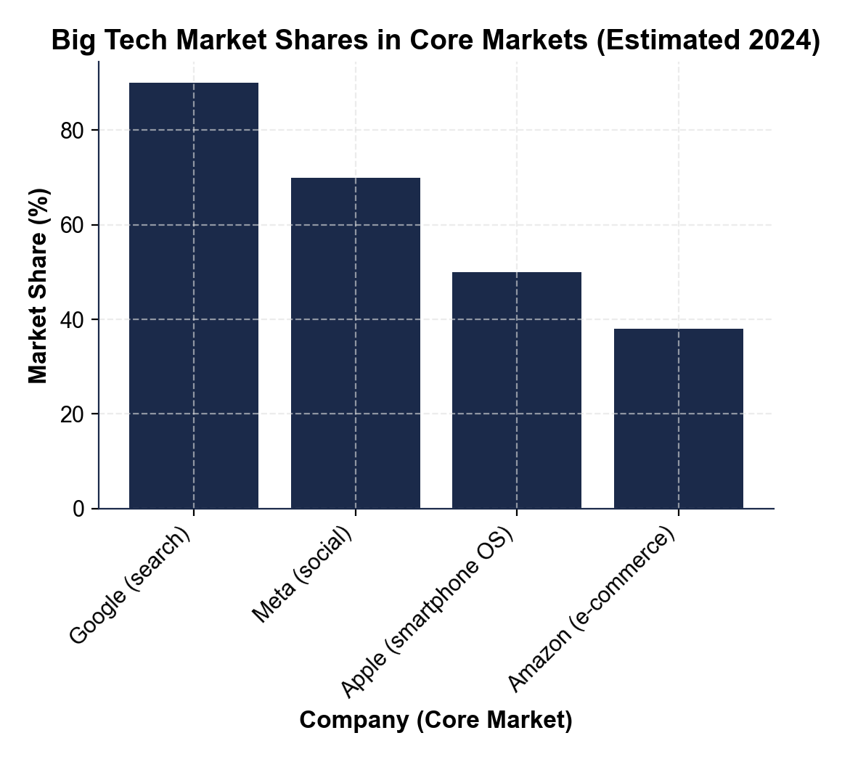
CHART REFERENCE 2: APPLE APP STORE COMMISSION - WHAT HAPPENS TO A $100 IN-APP PURCHASE
Use Chart Reference 2 (chart_app_store_commission) - the bar chart showing how a $100 in-app purchase is split between Apple commission and developer revenue shown below.
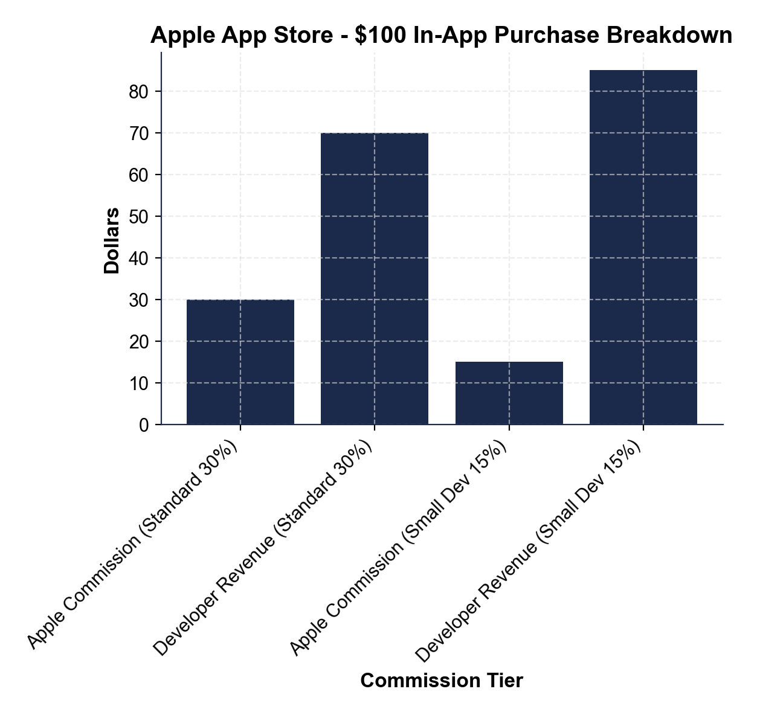
CHART REFERENCE 3: META (FACEBOOK) MAJOR ACQUISITIONS TIMELINE - THE FTC KILLER-ACQUISITION TARGETS
Use Chart Reference 3 (chart_meta_acquisitions) - the bar chart showing Meta's four major acquisitions with purchase prices and dates shown below.
