ECONOMICS

BIG TECH ANTITRUST - GOOGLE APPLE AMAZON META
ANSWER KEY ACTIVITY - ANSWER KEY

PART 1

Big Tech Antitrust Reference Guide - Complete the Missing Terms

Term | Definition
Monopoly | A market structure with ONE seller, no close substitutes for the product, and high barriers preventing new firms from entering; the single firm is a price-maker with significant market power
Network effects | When a product becomes more valuable to each user as MORE users join (Facebook is more valuable when your friends are on it; Google search is more accurate with more queries) - the most durable barrier to entry in digital markets
Self-preferencing | When a platform owner uses its dominant position to favor its own products over rivals on the same platform - Amazon promoting Amazon Basics over third-party sellers; Google placing Google Shopping above organic search - a central FTC and DOJ allegation
Walled garden | A platform that controls the user experience end-to-end and restricts what other companies can do inside it - Apple is the canonical walled garden; only Apple-approved apps run on iPhone, and Apple takes 15-30% of in-app purchases
Killer acquisition | When a dominant firm buys a smaller potential competitor specifically to eliminate it as a future threat - Meta's 2012 acquisition of Instagram and 2014 acquisition of WhatsApp are the FTC's primary examples; illegal under Clayton Act Section 7
Default search engine | The pre-installed pre-selected search engine on a device or browser; the August 2024 U.S. v. Google ruling found that Google's $20+ billion/year payments to Apple to be the default search on iPhones illegally maintained Google's search monopoly
Gatekeeper | The legal designation under the EU Digital Markets Act for a Big Tech platform with significant durable market position (40M+ EU users; 7.5B+ euro annual EU turnover) - six gatekeepers were designated in 2023 (Alphabet, Apple, Amazon, ByteDance, Meta, Microsoft)
Interoperability | When competing services can communicate with each other - your iPhone can text an Android phone seamlessly; your email account can email any other email account - the EU DMA mandates interoperability for messaging; U.S. cases increasingly demand it as a remedy
Sherman Act | The 1890 federal antitrust statute that bans monopolization (Section 2) and contracts or conspiracies in restraint of trade (Section 1) - the principal law underlying U.S. v. Google search (2024 ruling) and U.S. v. Apple (2024 filing)
Clayton Act | The 1914 federal antitrust statute that blocks anti-competitive mergers (Section 7) - the law underlying the FTC v. Meta challenge to the 2012 Instagram and 2014 WhatsApp acquisitions

PART 2

Apply the Terms - Big Tech Antitrust Vocabulary in Context
WORD BANK gatekeeper · killer acquisition · sherman act · self-preferencing · monopoly
1. Marcus opens with the core market structure. A market with ONE seller, no close substitutes, and high barriers that keep new firms out is a monopoly - the structure the four features describe.
monopoly. A monopoly has one seller, no close substitutes, and high barriers to entry, and the single firm is a price-maker with significant market power.
2. The FTC says Amazon ranks Amazon Basics above third-party listings in the Buy Box on its own marketplace. When a platform owner favors its OWN products over rivals on the same platform, that conduct is called self-preferencing.
self-preferencing. A platform owner uses its dominant position to favor its own products over competitors on the same platform - a central FTC and DOJ allegation against Amazon and Google.
3. Marcus points to Meta buying Instagram in 2012 and WhatsApp in 2014. When a dominant firm buys a smaller rising rival specifically to eliminate it as a future competitor, antitrust law calls that a killer acquisition.
killer acquisition
4. Under the EU Digital Markets Act, a Big Tech platform with a significant durable market position is given a special legal label. That designation - applied to Alphabet, Apple, Amazon, ByteDance, Meta, and Microsoft - is gatekeeper.
gatekeeper. The EU Digital Markets Act designation for a major Big Tech platform with a significant durable market position; six gatekeepers were named in 2023.
5. The 1890 federal statute that bans monopolization under Section 2 - the principal law behind the Google search and Apple cases - is the Sherman Act.
Sherman Act
PART 3

You Read the Three Big Tech Investigation Charts with Marcus Holt
1. Use Chart Reference 1 (chart_bigtech_market_shares) - the bar chart of Big Tech core-market shares for Google, Apple, Amazon, and Meta shown below - to evaluate which company has the strongest monopoly position.
(a) Read each of the four core-market shares off the chart.
SHARES (from the chart): Google ~90% general search, Meta ~70% social networks combined, Apple ~50% smartphone OS via iOS, Amazon ~38% e-commerce.
(b) Rank the four companies from HIGHEST to LOWEST share.
RANKING (high to low): 1. Google (90%), 2.
(c) Identify which company has the LOWEST share - and explain in 1-2 sentences why that company is still potentially a monopoly in a NARROW market definition.
LOWEST SHARE: Amazon at 38% of U.S. e-commerce. Amazon is still potentially a monopoly under the FTC's narrow market definition - the FTC defines the relevant market as the 'online superstore market' (Amazon + Walmart Marketplace + maybe Target.com), in which Amazon's share is much higher than 38%.
2. Use Chart Reference 2 (chart_app_store_commission) - the bar chart showing how a $100 in-app purchase is split between Apple commission and developer revenue shown below - to compute the App Store economic engine.
(a) Read the standard commission ($ amount) and standard developer revenue off the chart.
STANDARD (30% rate): Apple commission $30, developer revenue $70 on a $100 in-app purchase.
(b) Read the small-developer commission ($ amount) and small-developer revenue off the chart.
SMALL DEVELOPER (15% rate, developers under $1M/year): Apple commission $15, developer revenue $85.
(c) State the standard commission as a PERCENT.
STANDARD COMMISSION = 30% of the in-app purchase amount.
(d) In 1-2 sentences, explain why the 30% standard rate is the central economic issue in the DOJ Apple case and Epic Games v. Apple.
The 30% rate is the central economic issue because it is roughly 10x higher than typical credit-card processing (2-3%) and Apple captures this fee because there is NO alternative app store on iPhone in the U.S. Apple defends the commission as funding security, payment infrastructure, and developer tools.

3. Use Chart Reference 3 (chart_meta_acquisitions) - the bar chart showing Meta's four major acquisitions with purchase prices and dates shown below - to evaluate the FTC killer-acquisition allegation.
(a) Read the purchase price for each of the four Meta acquisitions (Instagram, WhatsApp, Oculus, CTRL-Labs).
PURCHASE PRICES: Instagram 2012 ($1 billion); WhatsApp 2014 ($19 billion); Oculus 2014 ($2 billion); CTRL-Labs 2019 ($1 billion).
(b) Identify which acquisition was the LARGEST in dollar terms.
LARGEST: WhatsApp 2014 at $19 billion - roughly 19x larger than the Instagram deal and the largest social/messaging acquisition in U.S. history at the time.
(c) Identify which TWO acquisitions are the FTC's primary killer-acquisition targets.
FTC TARGETS: Instagram (2012) and WhatsApp (2014). The FTC's December 2020 complaint seeks DIVESTITURE - forcing Meta to spin off both companies as separate firms.
(d) In 1-2 sentences, explain what makes an acquisition a KILLER ACQUISITION (and why Oculus and CTRL-Labs are not on the FTC target list).
A killer acquisition is when a dominant firm buys a smaller RISING RIVAL in the SAME core market specifically to ELIMINATE it as a future competitor. Instagram (2012) was a rising photo-sharing rival to Facebook; WhatsApp (2014) was a rising messaging rival to Facebook Messenger.
PART 4

Four Real Scenarios with Marcus Holt - Apply the Model
1. THE GOOGLE DEFAULT-SEARCH REMEDY.
Marcus walks you through the 2025 remedies phase scenario: Judge Mehta already ruled Google illegally maintained its search monopoly via default-search payments. Now he must decide the remedy. The DOJ proposes (a) ban Google from making any default-search payments to Apple/Samsung/Mozilla; (b) mandatory CHOICE SCREEN on every new device asking users to pick their search engine; (c) divestiture of Chrome browser. Apply NETWORK EFFECTS to each remedy: (a) Which remedy directly attacks network effects? (b) Which one only fights conduct? (c) Predict whether a choice screen would actually shift adult users from Google (and why).
(a) DIRECTLY ATTACKS NETWORK EFFECTS: divestiture of Chrome. A separate Chrome that does not default to Google would let Bing and DuckDuckGo accumulate query data (the network-effect input). Over time, that data builds rival search-quality - eroding the moat. (b) ONLY FIGHTS CONDUCT: banning default-search payments. This removes the illegal distribution tactic but leaves Google's existing 90% share and data moat intact. Choice screen is somewhere in between - removes the default lock-in but does not actively erode network effects. (c) A choice screen would probably NOT shift many adult users from Google. Most adults are habituated to Google and would tap Google on first prompt out of muscle memory. Choice screens might shift NEW users (children, new immigrants, users who pick the unfamiliar option). Real network-effect erosion requires a remedy stronger than choice screens - likely divestiture or interoperability mandates that force Google to share search data with rivals.
2. THE AMAZON BUY BOX SELF-PREFERENCING ANALYSIS. The FTC alleges Amazon's Buy Box algorithm favors Amazon Basics over third-party seller products on the same marketplace. Suppose you are a third-party seller of a $30 water bottle. Amazon Basics sells a similar water bottle for $25 - and the Buy Box defaults to the Amazon Basics product.
(a) Define SELF-PREFERENCING in 1 sentence.
SELF-PREFERENCING is when a platform owner uses its dominant position to favor its OWN products over rivals on the same platform - Amazon Basics over third-party seller products in the Buy Box.
(b) Identify the SPECIFIC competitive harm to you as the third-party seller.
SPECIFIC SELLER HARM: you (the third-party seller) lose sales because the Buy Box default goes to Amazon Basics even when your product has equivalent quality.
(c) Identify the SPECIFIC consumer harm (even though the Amazon Basics price is lower).
SPECIFIC CONSUMER HARM (even though Amazon Basics is cheaper): consumers see only ONE product (Amazon's) when they could be choosing between two. The Buy Box default removes the meaningful comparison shopping that Amazon's marketplace was supposed to enable.
(d) Recommend ONE remedy the FTC could seek that would directly address this self-preferencing conduct.
RECOMMENDED REMEDY: mandate ALGORITHM TRANSPARENCY + a NON-DISCRIMINATION RULE forcing Amazon's Buy Box algorithm to rank Amazon Basics and third-party products on the same neutral criteria (price, reviews, shipping speed) with no preference for the house brand. This is the EU Digital Markets Act approach (mandatory algorithm transparency for gatekeepers).
3. APPLE APP STORE INTEROPERABILITY. The EU Digital Markets Act forced Apple to allow THIRD-PARTY APP STORES on iPhones in the EU (effective 2024). Suppose the U.S. court in U.S. v. Apple orders the same remedy in 2026.
(a) Predict ONE specific way developer revenue would change.
DEVELOPER REVENUE: Many developers would launch in alternative app stores (like the Epic Games Store) that charge LOWER commissions (5-15% instead of 30%).
(b) Predict ONE specific way consumer behavior would change.
CONSUMER BEHAVIOR: Most casual consumers would stay with the Apple App Store (habit + trust + curation). Tech-savvy consumers and gamers would download alternative app stores to access cheaper apps or apps Apple banned (cloud gaming, alternative payment systems).
(c) Predict ONE specific way Apple's revenue would change.
APPLE REVENUE: Apple App Store commission revenue would DROP - potentially $3-5 billion/year in lost commissions. Apple would still earn money on iPhone hardware sales (the bigger revenue line) but the 30% Services growth engine would slow significantly.
(d) Marcus asks: would mandating INTEROPERABILITY between iMessage and WhatsApp (so green-bubble issues go away) attack a DIFFERENT walled-garden mechanism than third-party app stores - explain in 1-2 sentences.
iMessage INTEROPERABILITY attacks a DIFFERENT mechanism than third-party app stores. Third-party app stores attack the App Store DISTRIBUTION monopoly (developers cannot reach iPhone users any other way).
4. META DIVESTITURE MECHANICS. Suppose the FTC wins the 2025 Meta trial and the court orders Meta to DIVEST Instagram AND WhatsApp (force Meta to sell both as independent companies).
(a) Name the FOUR major Meta acquisitions from the chart and which TWO would be divested.
FOUR ACQUISITIONS: Instagram (2012, $1B); WhatsApp (2014, $19B); Oculus (2014, $2B); CTRL-Labs (2019, $1B). DIVESTED: Instagram and WhatsApp - the two killer-acquisition targets. Oculus and CTRL-Labs would stay with Meta.
(b) Predict what happens to USER experience after divestiture (e.g., do Instagram and Facebook still share login? Cross-post features?).
USER EXPERIENCE: Instagram becomes a separate company - cross-posting from Instagram to Facebook would likely END unless Meta and the new Instagram strike a commercial deal.
(c) Predict what happens to ADVERTISER behavior after divestiture.
ADVERTISER BEHAVIOR: Advertisers would have to buy from Meta (Facebook + Messenger), separate Instagram, and separate WhatsApp as THREE platforms instead of one.
(d) In 1-2 sentences, explain why DIVESTITURE is the FTC's preferred remedy here rather than CONDUCT RULES.
DIVESTITURE is preferred over CONDUCT RULES because the harm was the ACQUISITIONS themselves - Meta acquired rising rivals to eliminate competition. Conduct rules (no more killer acquisitions; allow cross-platform interoperability) would only prevent FUTURE harm; the existing Instagram and WhatsApp dominance would…
PART 5

Your Final Recommendation Memo to Marcus Holt
BIG TECH ANTITRUST RECOMMENDATION MEMO
1. Marcus closes the assignment.
You have rated all four companies, read the three charts, and walked four real scenarios with him, and now he needs your one-page recommendation for the team. Write a 6-8 sentence memo to Marcus that names which of the four Big Tech cases (Google search, Apple walled garden, Amazon self-preferencing, or Meta killer acquisitions) the government should prioritize for the strongest enforcement push, and that states the remedy the government should seek in that case. Use all four required terms - MONOPOLY, NETWORK EFFECTS, KILLER ACQUISITION, and DIVESTITURE - at least once each, and address every required element in the checklist below. Which Big Tech case should the DOJ and FTC prioritize, and what remedy should the government seek?
YOUR RESPONSE MUST:
☐ Names a SPECIFIC TARGET COMPANY (Google, Apple, Amazon, or Meta) for priority enforcement AND ties the choice to the MONOPOLY four-features model.
☐ Uses the term NETWORK EFFECTS correctly - explains how digital network effects make this case different from classical (Standard Oil, AT&T) monopoly cases.
☐ Uses the term KILLER ACQUISITION correctly - either when discussing Meta directly OR when contrasting Meta with the chosen target.
☐ Uses the term DIVESTITURE correctly - either recommends it as the remedy (and explains what gets sold off) OR explains why a non-structural remedy is better.
☐ Quotes at least ONE specific value from the chart appendix (Google ~90% market share, Apple 30% commission, $19B for WhatsApp, the 38% Amazon e-commerce share, or another specific number) to ground the recommendation in real data.
☐ Closes with a SPECIFIC PROCEDURAL NEXT STEP the DOJ or FTC should take in the next 12 months (e.g., file remedy proposal in Google case, depose specific Apple executives, subpoena Amazon Buy Box algorithm code, file motion for summary judgment in FTC v. Meta).
MEMO
To: Marcus Holt, Senior Antitrust Investigator, DOJ Antitrust Division
From: [student completes]
Date: [student completes]
Re: Big Tech Antitrust Priority and Remedy Recommendation
GRADING RUBRIC
Grade the evidence and reasoning, not the conclusion — any defensible position is valid. Score against the 6 requirements above.
FULL CREDIT — clear position; meets all 6 requirements with accurate, specific numbers and evidence from the lesson.
PARTIAL — position stated, but misses 1-2 requirements or uses vague / incorrect numbers.
MINIMAL — no clear position, or missing most requirements and numbers.
CHART REFERENCE 1: BIG TECH MARKET SHARES IN CORE MARKETS (ESTIMATED 2024)
Use Chart Reference 1 (chart_bigtech_market_shares) - the bar chart of Big Tech core-market shares for Google, Apple, Amazon, and Meta shown below.
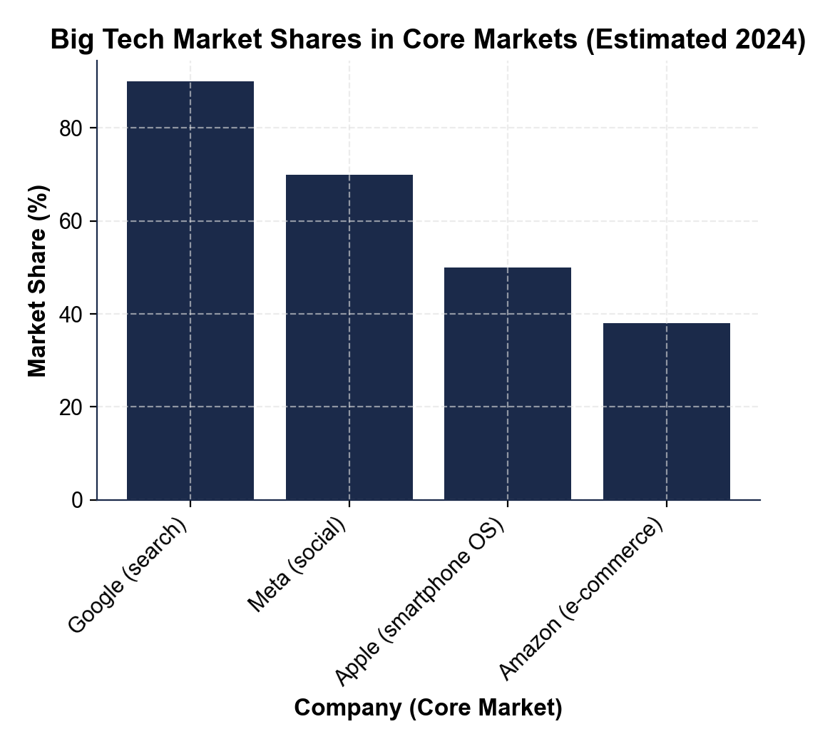
CHART REFERENCE 2: APPLE APP STORE COMMISSION - WHAT HAPPENS TO A $100 IN-APP PURCHASE
Use Chart Reference 2 (chart_app_store_commission) - the bar chart showing how a $100 in-app purchase is split between Apple commission and developer revenue shown below.
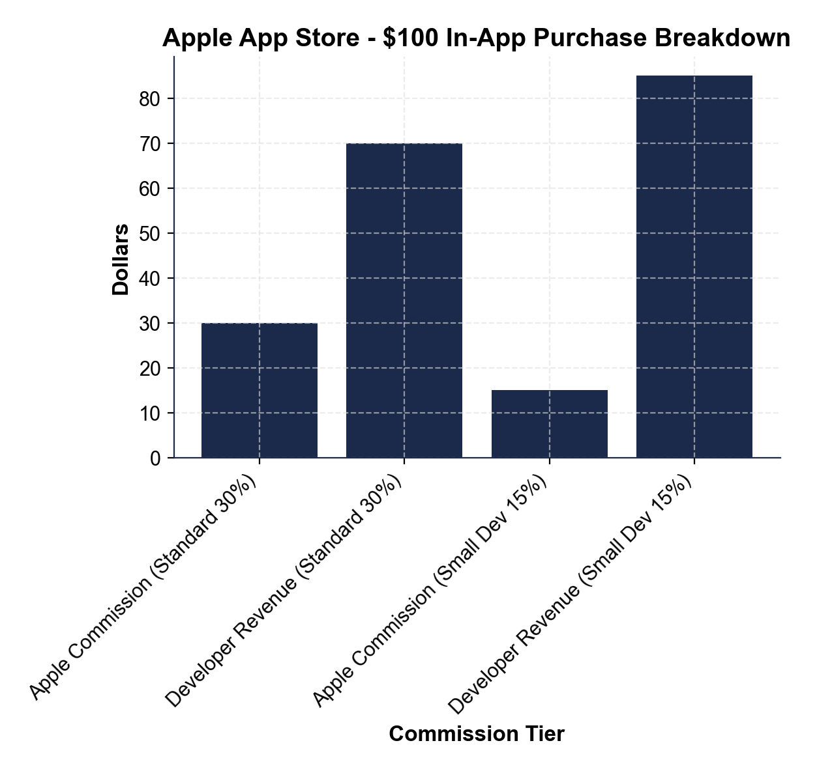
CHART REFERENCE 3: META (FACEBOOK) MAJOR ACQUISITIONS TIMELINE - THE FTC KILLER-ACQUISITION TARGETS
Use Chart Reference 3 (chart_meta_acquisitions) - the bar chart showing Meta's four major acquisitions with purchase prices and dates shown below.
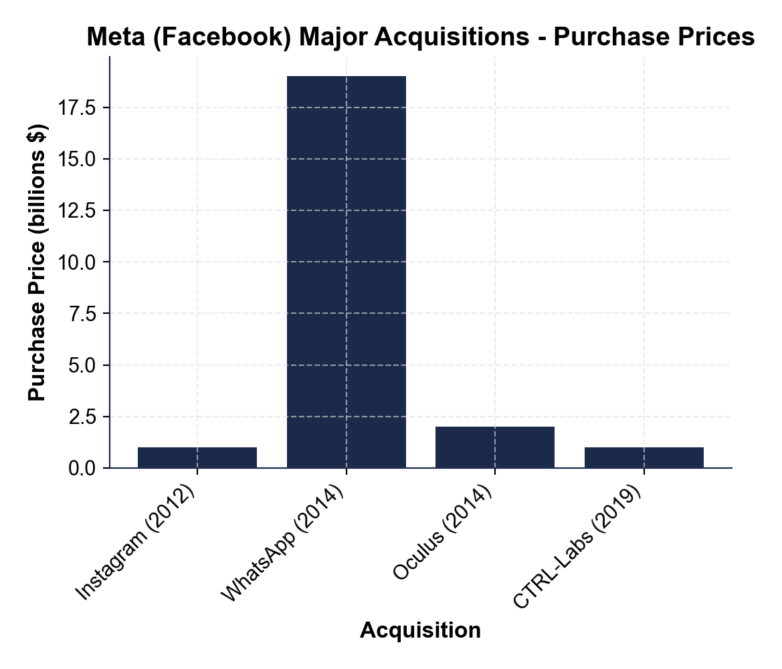

MORE LESSONS LESS PLANNING
Thank You!
If you enjoyed this product, please do not forget to rate and review to assist other teachers.

Looking for future discounts? Earn TPT credits by reviewing purchased products.

Please contact me if you have any issues with this product. Just like our students, I am always looking for opportunities to grow.

