Amazon Warehouses: Working Conditions Investigation
STUDENT ACTIVITY
Name: | Date: | Period:
ESSENTIAL QUESTION
What does Amazon's warehouse speed cost the people inside it?
THE SCENARIO
You are helping JORDAN REYES, a third-year OSHA compliance specialist at the New York State Department of Labor. Jordan is drafting an internal brief on Amazon's warehousing-injury data and the JFK8 unionization aftermath for an upcoming public hearing on whether NY State should recommend new regulations on warehouse productivity quotas.
BY THE END, YOU CAN:
✓ Describe working conditions and productivity quotas in Amazon fulfillment centers
✓ Trace the JFK8 (Staten Island) unionization win of April 1, 2022
✓ Evaluate Amazon's response, the broader labor implications, and how to interpret disputed injury data
HOW IT WORKS (do Parts 1–5 in order)
Part 1 — Jordan Reyes's Amazon Warehouses Reference Guide - Complete the missing rows
Part 2 — Apply the Terms - Amazon Warehouse Vocabulary in Context
Part 3 — You Read Chart 1 and Chart 2 with Jordan Reyes
Part 4 — Jordan Reyes's Six Stakeholders - Apply the Working-Conditions Framework
Part 5 — Your Final Synthesis Brief to Jordan's Director
TIME about 45 minutes YOU’LL NEED the lesson slides and your Guided Notes.

PART 1

Jordan Reyes's Amazon Warehouses Reference Guide - Complete the missing rows
Fill in the missing term for each blank row — the definition is your clue. Your Guided Notes and the lesson slides have every term.

Term | Definition
___________ | Amazon's term for its warehouse facility where workers receive, pack, and ship customer orders. Each center has a 3-4 character code (JFK8, LDJ5, ALB1) tied to its airport/location. JFK8 is the Staten Island, NY fulfillment center that unionized April 1, 2022.
The Rate (UPH) | Amazon's productivity quota measured in units per hour (UPH). Workers must hit a minimum number of items scanned, picked, or packed each hour. Workers can be auto-terminated by Amazon's system for sustained underperformance. The Rate is the most-cited grievance in Amazon worker organizing.
___________ | Amazon's automated tracking of any time a worker is not actively scanning or moving products - includes bathroom breaks, equipment problems, and stretching. Sustained TOT can trigger discipline. The TOT system is widely cited as creating pressure to skip bathroom breaks.
OSHA recordable injury | A workplace injury serious enough to require time off work, restricted duty, or medical treatment beyond first aid. Tracked on OSHA Form 300A. Rate is measured per 100 full-time workers per year. Amazon's recordable rate (6.6 in 2022) is roughly double the non-Amazon warehousing industry average (3.2).
___________ | Days Away, Restricted, or Transferred - a BLS injury metric that counts how many recordable injuries led to lost workdays, work restrictions, or job transfers. A subset of total recordable injuries. Amazon cites DART rate improvements year-over-year in its safety reports.
NLRB | National Labor Relations Board. The federal agency that supervises union elections and enforces U.S. labor law (the National Labor Relations Act of 1935). The NLRB conducted the JFK8 vote on April 1, 2022, certified the result months later after Amazon filed 25+ objections.
___________ | Independent worker-led union founded in 2021 by Chris Smalls and other Amazon workers in Staten Island. NOT affiliated with any major established union (Teamsters, SEIU). Won JFK8 vote April 1, 2022 - the first successful Amazon union in U.S. history.
Union election | A formal NLRB-supervised vote where workers at a single worksite decide whether to be represented by a union for collective bargaining. Requires support from at least 30% of workers to call the election; a simple majority of those voting wins recognition.
___________ | A paid consultant hired by an employer to discourage workers from unionizing. Legal under U.S. labor law if reported to the Department of Labor via Form LM-10. Amazon spent ~$14.2 million on consultants company-wide in 2022 per its LM-10 filings.
Collective bargaining | The legally protected process where a union negotiates wages, benefits, and working conditions for ALL workers at a worksite at once - instead of each worker negotiating alone. Backed by the National Labor Relations Act of 1935. JFK8 entered collective bargaining with Amazon after winning certification.

PART 2

Apply the Terms - Amazon Warehouse Vocabulary in Context
WORD BANK election · recordable · the rate · collective bargaining · time task
1. A JFK8 picker must scan about 300 items every hour, and Amazon's system can auto-terminate a worker who falls short. This productivity quota, measured in units per hour, is called .

2. An Amazon worker pulls a rotator cuff lifting a 40-pound package and needs three days off plus physical therapy. Because it required time off and treatment beyond first aid, it is logged on Form 300A as an OSHA injury.

3. Amazon's system flags every minute a JFK8 worker is not actively scanning, including a 7-minute bathroom break. This automated tracking is called off .

4. On April 1, 2022, JFK8 workers cast ballots in a formal NLRB-supervised vote on whether the ALU would represent them. A worksite vote on union representation is called a union .

5. After winning the JFK8 vote, the ALU negotiated wages, schedules, and working conditions for all JFK8 workers at once instead of each worker bargaining alone. This protected negotiating process is called .

PART 3

You Read Chart 1 and Chart 2 with Jordan Reyes
1. Use Chart Reference 1 (chart_injury_rates_amazon_vs_industry) - the bar chart of Amazon vs non-Amazon warehousing recordable injury rates 2021-2022 in the appendix - to extract these values.
(a) What was Amazon's 2021 recordable injury rate per 100 workers?

(b) What was the non-Amazon warehousing rate in 2021?

(c) Which two bars are highlighted in coral on the chart?

2. Looking at Chart 1, what were the 2022 values for Amazon AND non-Amazon warehousing? Calculate Amazon's 2022 rate divided by the non-Amazon 2022 rate (round to one decimal place).
What does that ratio mean in plain English?

3. Amazon disputes the comparison in Chart 1. State BOTH of Amazon's main counter-arguments in your own words. Then explain in 1-2 sentences why an independent third-party audit would help settle the dispute.

4. Use Chart Reference 2 (chart_amazon_unionization_votes) - the bar chart of three 2022 Amazon NLRB votes - to extract these values.
(a) What percentage of JFK8 workers voted YES?

(b) What percentage voted YES at LDJ5?

(c) What percentage voted YES at ALB1?

(d) Which bar is highlighted in coral?

5. Compare JFK8 (55% YES) to ALB1 (33% YES) on Chart 2.
(a) Calculate the gap in percentage points.

(b) Explain in 2-3 sentences why JFK8 won while LDJ5 and ALB1 both lost - reference at least one specific organizing factor.

PART 4

Jordan Reyes's Six Stakeholders - Apply the Working-Conditions Framework
1. JFK8 WAREHOUSE WORKER who voted YES in the April 1, 2022 vote - was their position made BETTER, WORSE, or MIXED by the JFK8 union win? Justify in 2-3 sentences using a specific fact from the lesson.

2. AMAZON PRIME CUSTOMER who orders 5-10 items per month with same-day delivery - better, worse, or mixed after JFK8? Justify in 2-3 sentences using a specific fact from the lesson.

3. CHRIS SMALLS, founder of the ALU - better, worse, or mixed after JFK8? Justify in 2-3 sentences using a specific fact from the lesson.

4. AMAZON CORPORATE (Bezos-era executive team and shareholders) - better, worse, or mixed after JFK8? Justify in 2-3 sentences using a specific fact from the lesson.

5. OSHA INSPECTOR responsible for warehousing enforcement in the Northeast region - better, worse, or mixed after JFK8 + the 2023 OSHA citation? Justify in 2-3 sentences using a specific fact from the lesson.

6. WALMART WAREHOUSE WORKER at a competing warehouse (NOT Amazon) watching JFK8 - better, worse, or mixed for their union's NEXT contract or organizing drive? Justify in 2-3 sentences using a specific fact from the lesson.

PART 5

Your Final Synthesis Brief to Jordan's Director
SYNTHESIS BRIEF
1. Jordan needs a one-page recommendation for the NY State Department of Labor hearing, drawing on your work in Parts 1-4 and citing both charts.
Should NY State recommend new regulations on warehouse productivity quotas?
YOUR RESPONSE MUST:
☐ Takes a clear position (RECOMMEND new regulation / RECOMMEND NO new regulation / RECOMMEND further study).
☐ Cites at least ONE specific value from Chart 1 (chart_injury_rates_amazon_vs_industry) - e.g., 6.8, 6.6, 3.3, 3.2, or "roughly 2x".
☐ Cites at least ONE specific value from Chart 2 (chart_amazon_unionization_votes) - e.g., 55%, 38%, 33%, or "22 percentage point gap".
☐ Presents BOTH the union framing (rate gap) AND Amazon's methodology counter-argument (wrong peer group / more rigorous reporting).
☐ Recommends ONE specific regulation OR explicitly recommends no new regulation - with a concrete reason tied to OSHA or NLRB evidence.
☐ Names at least ONE specific stakeholder the recommendation will impact (worker, customer, Amazon corporate, OSHA, competitor warehouse).
☐ Written as a 5-7 sentence memo in a balanced, professional tone.
MEMO
To: Jordan Reyes, OSHA Compliance Specialist - NY DOL
From:
Date:
Re: Recommendation on warehouse productivity quota regulation

CHART REFERENCE 1 - AMAZON VS NON-AMAZON WAREHOUSING RECORDABLE INJURY RATES (2021-2022)
chart_injury_rates_amazon_vs_industry
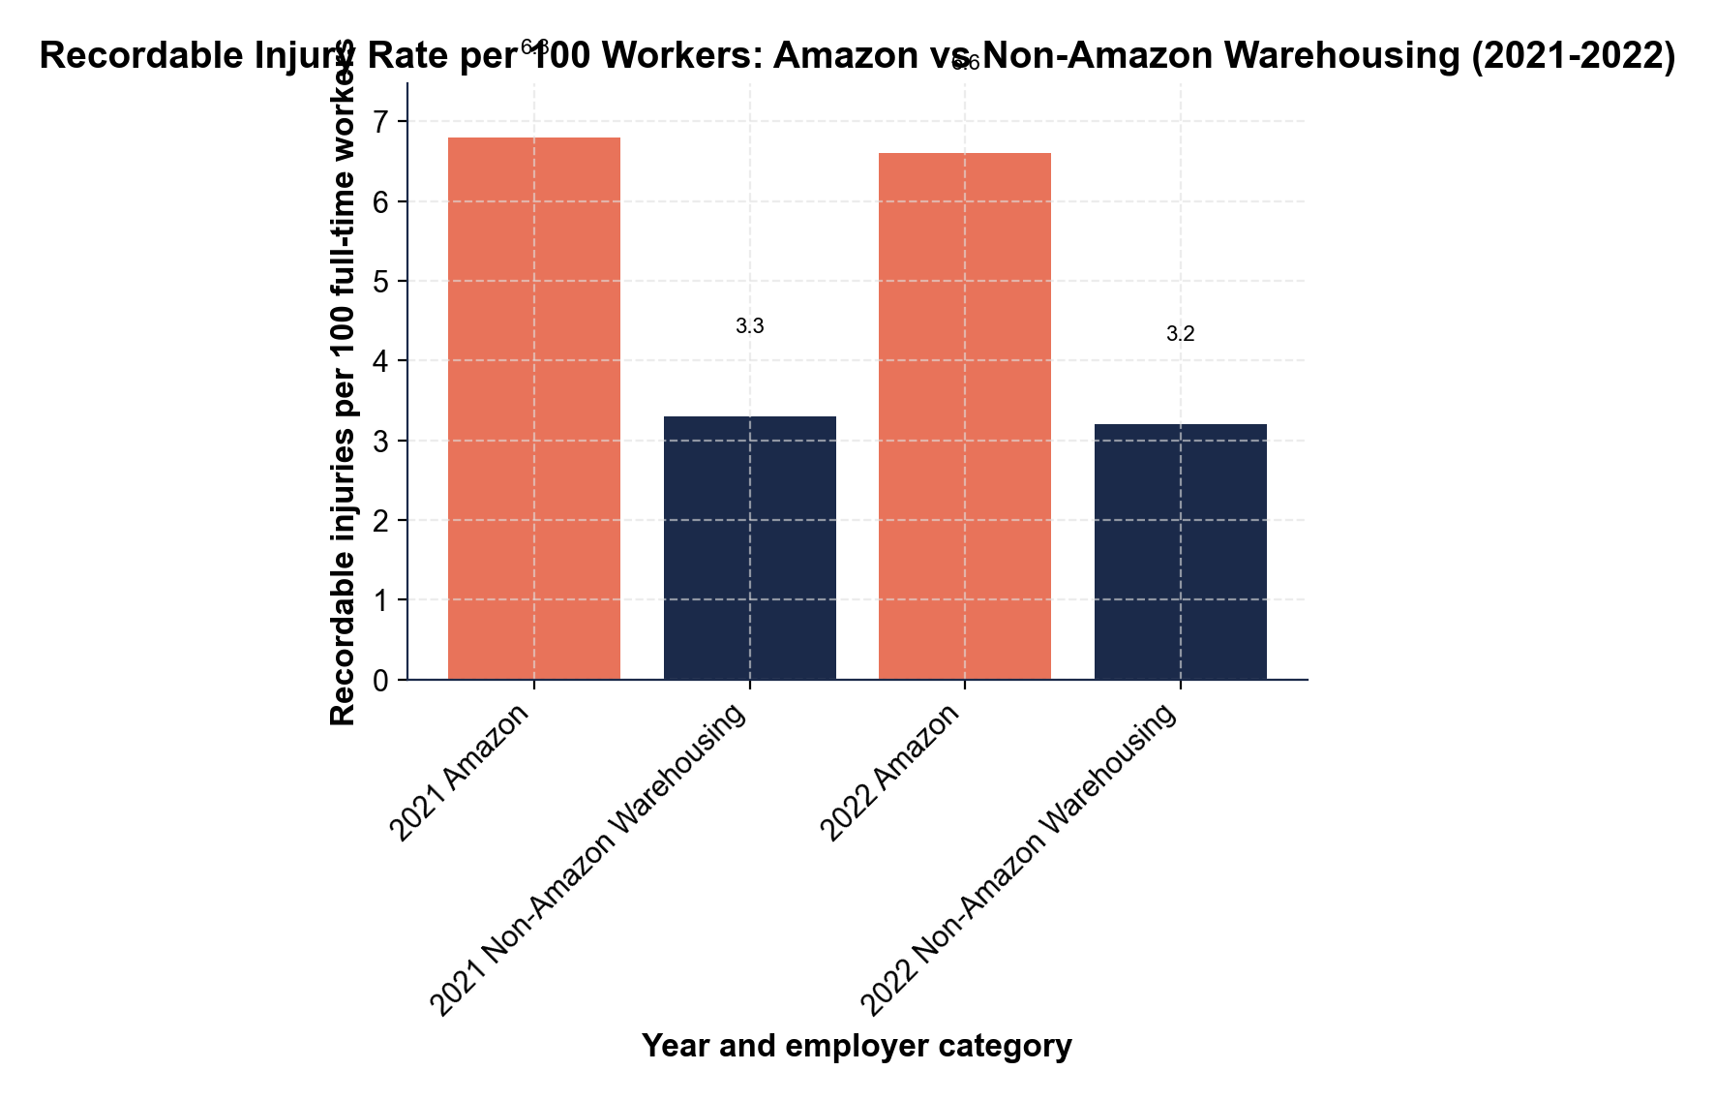
CHART REFERENCE 2 - AMAZON UNIONIZATION VOTE RESULTS BY SITE (2022)
chart_amazon_unionization_votes
