ECONOMICS

AMAZON WAREHOUSES: WORKING CONDITIONS INVESTIGATION
ANSWER KEY ACTIVITY - ANSWER KEY

PART 1

Jordan Reyes's Amazon Warehouses Reference Guide - Complete the missing rows

Term | Definition
Fulfillment center | Amazon's term for its warehouse facility where workers receive, pack, and ship customer orders. Each center has a 3-4 character code (JFK8, LDJ5, ALB1) tied to its airport/location. JFK8 is the Staten Island, NY fulfillment center that unionized April 1, 2022.
The Rate (UPH) | Amazon's productivity quota measured in units per hour (UPH). Workers must hit a minimum number of items scanned, picked, or packed each hour. Workers can be auto-terminated by Amazon's system for sustained underperformance. The Rate is the most-cited grievance in Amazon worker organizing.
Time off task (TOT) | Amazon's automated tracking of any time a worker is not actively scanning or moving products - includes bathroom breaks, equipment problems, and stretching. Sustained TOT can trigger discipline. The TOT system is widely cited as creating pressure to skip bathroom breaks.
OSHA recordable injury | A workplace injury serious enough to require time off work, restricted duty, or medical treatment beyond first aid. Tracked on OSHA Form 300A. Rate is measured per 100 full-time workers per year. Amazon's recordable rate (6.6 in 2022) is roughly double the non-Amazon warehousing industry average (3.2).
DART rate | Days Away, Restricted, or Transferred - a BLS injury metric that counts how many recordable injuries led to lost workdays, work restrictions, or job transfers. A subset of total recordable injuries. Amazon cites DART rate improvements year-over-year in its safety reports.
NLRB | National Labor Relations Board. The federal agency that supervises union elections and enforces U.S. labor law (the National Labor Relations Act of 1935). The NLRB conducted the JFK8 vote on April 1, 2022, certified the result months later after Amazon filed 25+ objections.
Amazon Labor Union (ALU) | Independent worker-led union founded in 2021 by Chris Smalls and other Amazon workers in Staten Island. NOT affiliated with any major established union (Teamsters, SEIU). Won JFK8 vote April 1, 2022 - the first successful Amazon union in U.S. history.
Union election | A formal NLRB-supervised vote where workers at a single worksite decide whether to be represented by a union for collective bargaining. Requires support from at least 30% of workers to call the election; a simple majority of those voting wins recognition.
Union avoidance consultant | A paid consultant hired by an employer to discourage workers from unionizing. Legal under U.S. labor law if reported to the Department of Labor via Form LM-10. Amazon spent ~$14.2 million on consultants company-wide in 2022 per its LM-10 filings.
Collective bargaining | The legally protected process where a union negotiates wages, benefits, and working conditions for ALL workers at a worksite at once - instead of each worker negotiating alone. Backed by the National Labor Relations Act of 1935. JFK8 entered collective bargaining with Amazon after winning certification.

PART 2

Apply the Terms - Amazon Warehouse Vocabulary in Context
WORD BANK election · recordable · the rate · collective bargaining · time task
1. A JFK8 picker must scan about 300 items every hour, and Amazon's system can auto-terminate a worker who falls short. This productivity quota, measured in units per hour, is called the Rate.
the Rate
2. An Amazon worker pulls a rotator cuff lifting a 40-pound package and needs three days off plus physical therapy. Because it required time off and treatment beyond first aid, it is logged on Form 300A as an OSHA recordable injury.
recordable. An OSHA recordable injury requires time off work, restricted duty, or medical treatment beyond first aid, and is tracked on Form 300A as a rate per 100 full-time workers per year.
3. Amazon's system flags every minute a JFK8 worker is not actively scanning, including a 7-minute bathroom break. This automated tracking is called time off task.
time task
4. On April 1, 2022, JFK8 workers cast ballots in a formal NLRB-supervised vote on whether the ALU would represent them. A worksite vote on union representation is called a union election.
election. A union election is a formal NLRB-supervised vote where workers at one worksite decide whether to be represented; 30 percent support is needed to file, and a simple majority wins.
5. After winning the JFK8 vote, the ALU negotiated wages, schedules, and working conditions for all JFK8 workers at once instead of each worker bargaining alone. This protected negotiating process is called collective bargaining.
collective bargaining
PART 3

You Read Chart 1 and Chart 2 with Jordan Reyes
1. Use Chart Reference 1 (chart_injury_rates_amazon_vs_industry) - the bar chart of Amazon vs non-Amazon warehousing recordable injury rates 2021-2022 in the appendix - to extract these values.
(a) What was Amazon's 2021 recordable injury rate per 100 workers?
2021 Amazon: 6.8 recordable injuries per 100 workers - the first coral bar.
(b) What was the non-Amazon warehousing rate in 2021?
2021 Non-Amazon warehousing: 3.3 per 100 workers - the first navy bar.
(c) Which two bars are highlighted in coral on the chart?
The two CORAL-highlighted bars are 2021 Amazon (6.8) and 2022 Amazon (6.6). The non-Amazon warehousing bars (3.3 in 2021 and 3.2 in 2022) are shown in NAVY.
2. Looking at Chart 1, what were the 2022 values for Amazon AND non-Amazon warehousing? Calculate Amazon's 2022 rate divided by the non-Amazon 2022 rate (round to one decimal place).
What does that ratio mean in plain English?
2022 Amazon: 6.6 per 100 workers. 2022 Non-Amazon warehousing: 3.2 per 100.
3. Amazon disputes the comparison in Chart 1. State BOTH of Amazon's main counter-arguments in your own words. Then explain in 1-2 sentences why an independent third-party audit would help settle the dispute.
Amazon's two main counter-arguments: (1) "General warehousing" is the WRONG peer comparison group - Amazon argues the right comparison is other e-commerce / fulfillment operations, not all warehouse types (auto parts, lumber, cold storage, etc.). (2) Amazon classifies MORE incidents as recordable because its EHS (environment, health, safety) reporting is more rigorous than peer companies' - so the rate gap may partly reflect MORE COMPLETE reporting, not necessarily MORE actual injuries. An independent third-party audit would settle it because it would: (a) use a single consistent standard across Amazon AND peer companies; (b) verify that Amazon's "more rigorous reporting" claim is real (or not); (c) be conducted by someone with no financial stake in the outcome. Amazon has not agreed to one.

4. Use Chart Reference 2 (chart_amazon_unionization_votes) - the bar chart of three 2022 Amazon NLRB votes - to extract these values.
(a) What percentage of JFK8 workers voted YES?
JFK8 (April 2022): 55% YES.
(b) What percentage voted YES at LDJ5?
LDJ5 (May 2022): 38% YES.
(c) What percentage voted YES at ALB1?
ALB1 (October 2022): 33% YES.
(d) Which bar is highlighted in coral?
The CORAL bar is JFK8 - it is the only site that WON. LDJ5 and ALB1 are shown in NAVY because they both LOST.
5. Compare JFK8 (55% YES) to ALB1 (33% YES) on Chart 2.
(a) Calculate the gap in percentage points.
Gap: 55 - 33 = 22 percentage points. JFK8 had 22 percentage points MORE YES support than ALB1 had.
(b) Explain in 2-3 sentences why JFK8 won while LDJ5 and ALB1 both lost - reference at least one specific organizing factor.
JFK8 won while the other two lost because of SITE-SPECIFIC organizing strength, not industry-wide momentum. Chris Smalls and the independent ALU spent over a year building worker-to-worker contact at JFK8 specifically - tabling at the bus stop, cooking food for night-shift workers, using TikTok and GoFundMe to fund…
PART 4

Jordan Reyes's Six Stakeholders - Apply the Working-Conditions Framework
1. JFK8 WAREHOUSE WORKER who voted YES in the April 1, 2022 vote - was their position made BETTER, WORSE, or MIXED by the JFK8 union win? Justify in 2-3 sentences using a specific fact from the lesson.
MIXED to BETTER (long-term). The JFK8 vote gave workers federal recognition of their union (the ALU) and the legal right to collective bargaining - that is the legal floor that did not exist before.
2. AMAZON PRIME CUSTOMER who orders 5-10 items per month with same-day delivery - better, worse, or mixed after JFK8? Justify in 2-3 sentences using a specific fact from the lesson.
MOSTLY UNCHANGED so far - the JFK8 vote has NOT yet translated into contract terms that would force Amazon to slow fulfillment or raise wages enough to affect Prime pricing.
3. CHRIS SMALLS, founder of the ALU - better, worse, or mixed after JFK8? Justify in 2-3 sentences using a specific fact from the lesson.
BETTER on public profile, MIXED on movement-building. Smalls became one of the best-known U.S. labor organizers of the 2020s after JFK8 - testifying before Congress, appearing on national media, becoming a recognizable face for worker-led organizing.
4. AMAZON CORPORATE (Bezos-era executive team and shareholders) - better, worse, or mixed after JFK8? Justify in 2-3 sentences using a specific fact from the lesson.
MIXED, tilted to slight LOSS but contained. The JFK8 vote was the first crack in Amazon's union-free U.S. record - a real symbolic loss.
5. OSHA INSPECTOR responsible for warehousing enforcement in the Northeast region - better, worse, or mixed after JFK8 + the 2023 OSHA citation? Justify in 2-3 sentences using a specific fact from the lesson.
BETTER (modestly). The 2023 OSHA citation of Amazon (~$60K for ergonomic hazards) plus the JFK8 union's public attention to working conditions raised the priority of warehouse-injury enforcement at the federal level.
6. WALMART WAREHOUSE WORKER at a competing warehouse (NOT Amazon) watching JFK8 - better, worse, or mixed for their union's NEXT contract or organizing drive? Justify in 2-3 sentences using a specific fact from the lesson.
BETTER (modestly). The JFK8 vote established that algorithmically-managed warehouse workers CAN unionize, even against well-funded employer opposition.
PART 5

Your Final Synthesis Brief to Jordan's Director
SYNTHESIS BRIEF
1. Jordan needs a one-page recommendation for the NY State Department of Labor hearing, drawing on your work in Parts 1-4 and citing both charts.
Should NY State recommend new regulations on warehouse productivity quotas?
YOUR RESPONSE MUST:
☐ Takes a clear position (RECOMMEND new regulation / RECOMMEND NO new regulation / RECOMMEND further study).
☐ Cites at least ONE specific value from Chart 1 (chart_injury_rates_amazon_vs_industry) - e.g., 6.8, 6.6, 3.3, 3.2, or "roughly 2x".
☐ Cites at least ONE specific value from Chart 2 (chart_amazon_unionization_votes) - e.g., 55%, 38%, 33%, or "22 percentage point gap".
☐ Presents BOTH the union framing (rate gap) AND Amazon's methodology counter-argument (wrong peer group / more rigorous reporting).
☐ Recommends ONE specific regulation OR explicitly recommends no new regulation - with a concrete reason tied to OSHA or NLRB evidence.
☐ Names at least ONE specific stakeholder the recommendation will impact (worker, customer, Amazon corporate, OSHA, competitor warehouse).
☐ Written as a 5-7 sentence memo in a balanced, professional tone.
MEMO
To: Jordan Reyes, OSHA Compliance Specialist - NY DOL
From: [student completes]
Date: [student completes]
Re: Recommendation on warehouse productivity quota regulation
GRADING RUBRIC
Grade the evidence and reasoning, not the conclusion — any defensible position is valid. Score against the 7 requirements above.
FULL CREDIT — clear position; meets all 7 requirements with accurate, specific numbers and evidence from the lesson.
PARTIAL — position stated, but misses 1-2 requirements or uses vague / incorrect numbers.
MINIMAL — no clear position, or missing most requirements and numbers.
CHART REFERENCE 1 - AMAZON VS NON-AMAZON WAREHOUSING RECORDABLE INJURY RATES (2021-2022)
chart_injury_rates_amazon_vs_industry
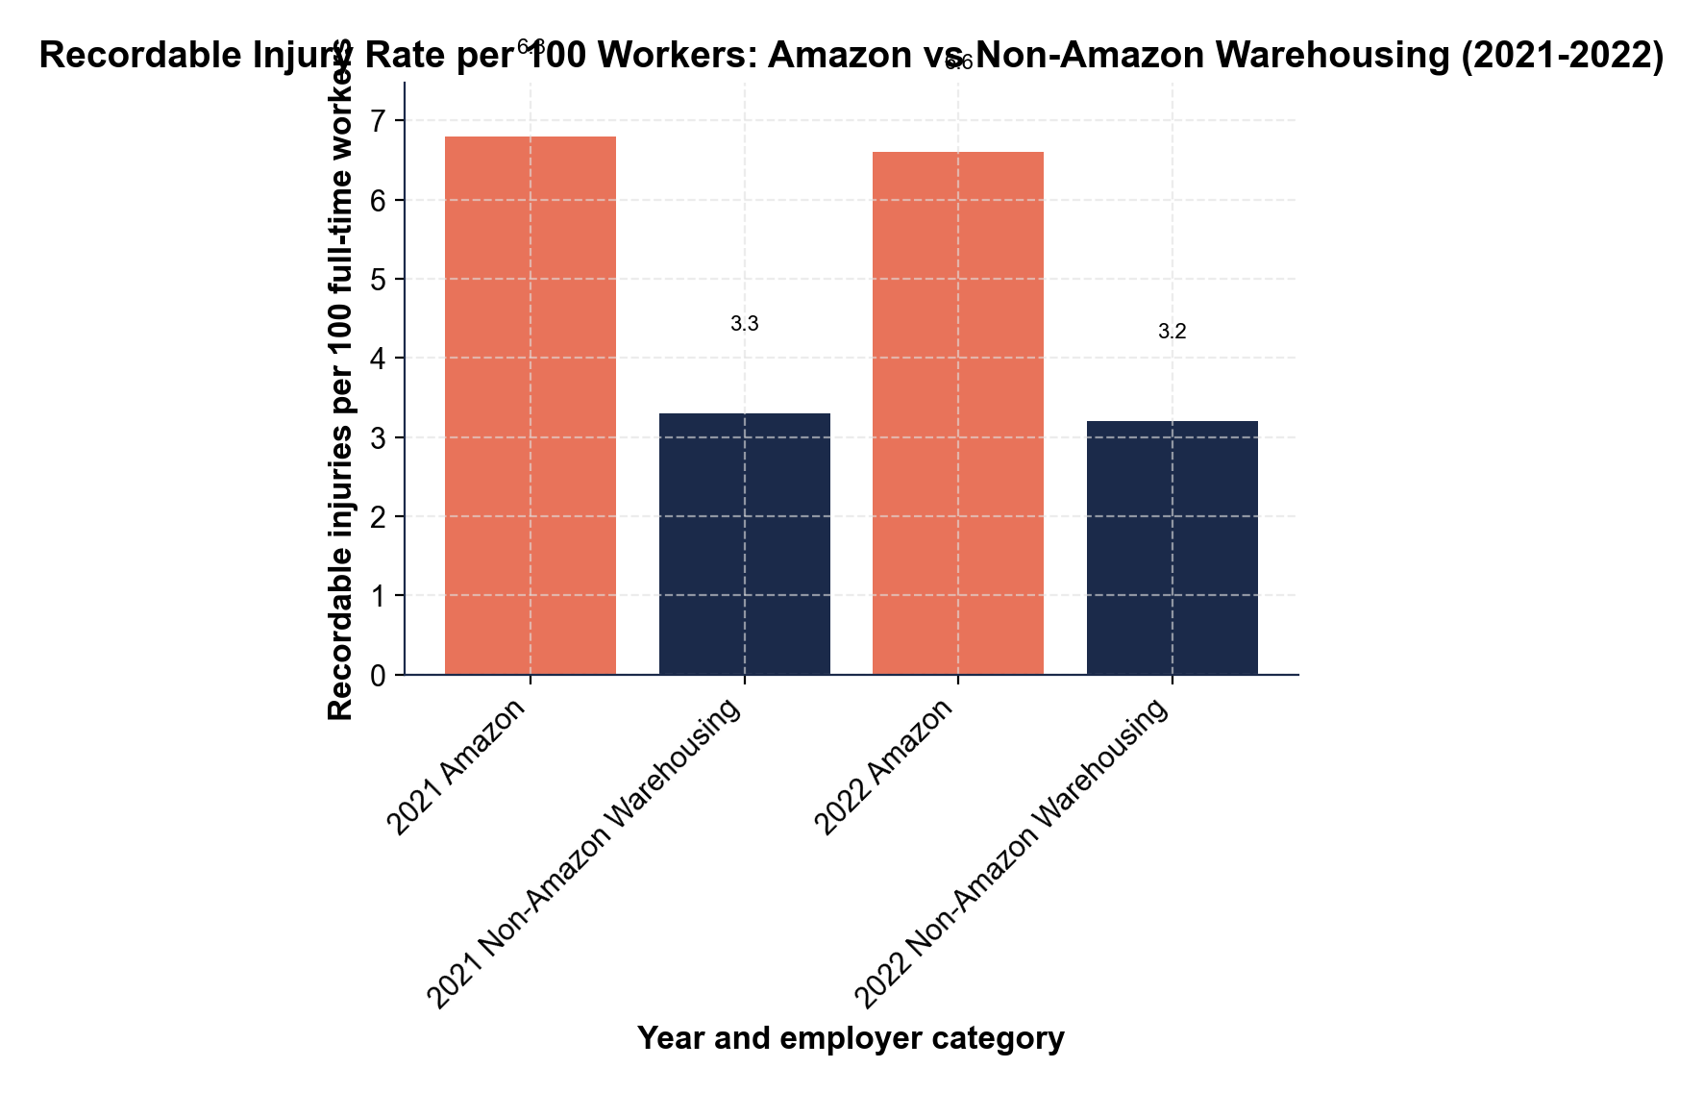
CHART REFERENCE 2 - AMAZON UNIONIZATION VOTE RESULTS BY SITE (2022)
chart_amazon_unionization_votes
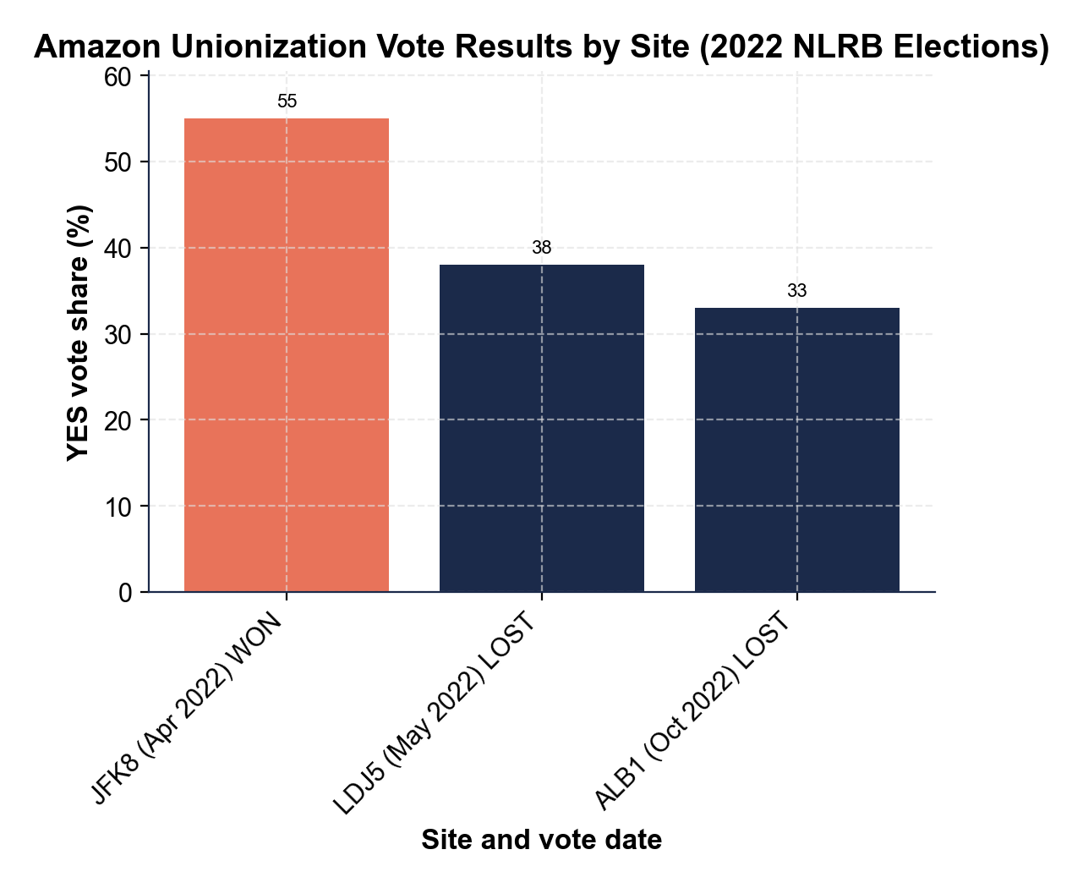

MORE LESSONS LESS PLANNING
Thank You!
If you enjoyed this product, please do not forget to rate and review to assist other teachers.

Looking for future discounts? Earn TPT credits by reviewing purchased products.

Please contact me if you have any issues with this product. Just like our students, I am always looking for opportunities to grow.

